

|  |
| --- |
| Name: Kaveena Isuri Wijesinghe |
| Student Reference Number: 10638375 |

|  |  |  |
| --- | --- | --- |
| Module Code: ISAD253SL | Module Name: Databases | |
| Coursework Title: Flight Management System | | |
| Deadline Date: 02/01/2019 | | Member of staff responsible for coursework: Ms. Dileeka Alwis |
| Programme: Bsc (Hons) Software Engineering(4872) | | |
| Please note that University Academic Regulations are available under Rules and Regulations on the University website [www.plymouth.ac.uk/studenthandbook](http://www.plymouth.ac.uk/studenthandbook). | | |
| Group work: please list all names of all participants formally associated with this work and state whether the work was undertaken alone or as part of a team. Please note you may be required to identify individual responsibility for component parts.  Kaveena Isuri Wijesinghe 10638375  ***We confirm that we have read and understood the Plymouth University regulations relating to Assessment Offences and that we are aware of the possible penalties for any breach of these regulations. We confirm that this is the independent work of the group.***  Signed on behalf of the group: Aruni Liyanage | | |
| Individual assignment: ***I confirm that I have read and understood the Plymouth University regulations relating to Assessment Offences and that I am aware of the possible penalties for any breach of these regulations. I confirm that this is my own independent work.***  Signed : | | |
| Use of translation software: failure to declare that translation software or a similar writing aid has been used will be treated as an assessment offence.  I *have used/not used translation software.  If used, please state name of software………………………………………………………………… | | |
| **Overall mark _____% Assessors Initials ______ Date_________** | | |

*Please delete as appropriateSci/ps/d:/students/cwkfrontcover/2013/14



**Databases – ISAD253SL**

**Coursework 2018 – 2019**

Table of Contents

1. Section 1 4

Acknowledgment………………………………………………………………………………………………………………………..4

1.1. Introduction 4

1.2. Extended Entity Relationship Diagram 5

1.3. Assumptions 6

1.4. Relational Mapping 7

1.5. Normalization 8

1.6. Dictionary 13

2. Section 2 16

2.1. Microsoft SQL Sever Create Tables & Statement 16

2.2. Database Diagram 27

2.3. Sample Records 28

3. Section 3 44

3.1. Microsoft SQL Server Create Trigger Statement 44

3.2. Microsoft SQL Server Create View Statements 48

3.3. Microsoft SQL Server Create Procedure Statements 50

4. Section 4 52

4.1. Future Implementation………………………………………………………………………………………………………….52

4.2. Work Load Matrix 52

4.3. Peer Evaluation Form for Group Work 53

# Section 1

Acknowledgment

According to the ISAD253SL course work, making such a construction based course work was a bit challenging task for all the group members of our group. But it was became much easy , because our module leader Ms. Dileeka Alwis proper guidance us. She has supported a lot in making this system. All the group members of our team gave their maximum tiredness and spent a much time for the team to succeed our course work.

## 1.1. Introduction

According to the ISAD253SL course work, a Flight management system database should be made. This database is made for Mihin air international airport in Sri Lanka. It is planning to activate a new database to improve the skill management system. This database requires to store details and details of international airports operated through Mihin Air, daily schedule flights and passenger check in information and seat booking details.

Database of each airports and each airlines represents with unique code assigned by the international air transport Association And also Airlines typically use a unique flight numbers. Each flight is scheduled for multiple flight legs per week. This leg has a unique numbers, date of flight, actual time etc.

If the flight leg is delayed or cancelled a special remarks included to the database with the reason .The details about the air crew and the passengers should be recorded in the database. A passenger can book a seat in any flight leg while it can be book by any number of passengers. Ticket number and class of travel are recorded in the database.

According to the rules of airline, passenger must have a seat except an infant. All the details of air crew employees include such as, staff ID, passport number, date joined, qualifications and working experience etc.

This new system should have facilities to display the seat booking details of each flight leg and should be capable of assigning an available seat to a new passenger. The boarding pass of passenger also should be printed with the necessary information along with the seat number and the gate number include as a result of the new system.

## 1.2. EER

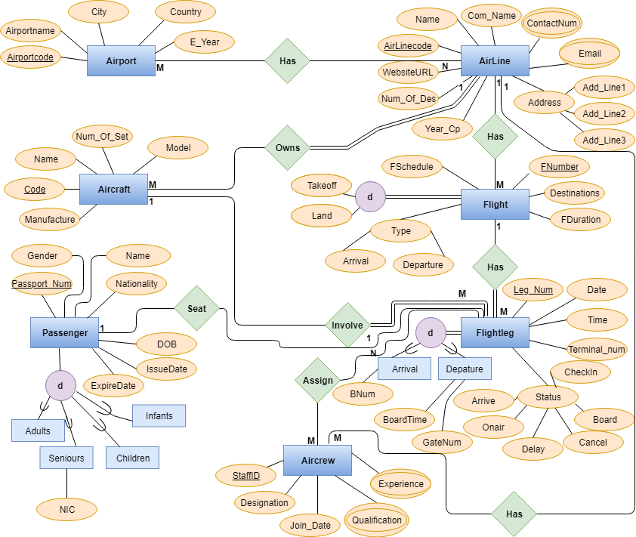

## 1.3. Assumptions

## 1:1

* Passenger : Flightleg

One Passenger have one Flightleg and One Flightleg have one Passenger

1:M

* AirLine : AirCraft

One AirLine has many AirCraft.But,Many AirCraft have only one AirLine.

* AirLine : Flight

Only one AirLine have to many Flight and Many Flight have only one AirLine.

* Flight : Flightleg

One Flight has Many Flightleg.But,Many Flight has only one Flight.

* AirCraft : Flightleg

One AirCraft Involved to many Flightleg.But,Many Flightleg involved to only one AirCraft.

* AirLine:AirCrew

One AirLine have to many AirCrew and many AirCrew have only one AirLine.

M:N

* AirPort : AirLine

One Airport have many AirLine and only one AirLine have many AirPort.

* AirCrew : Flightleg

One AirCrew have Many Flightleg and Onlyone Flightleg have many AirCrew.

## 1.4. Relational Mapping

## 1.5. Normalization

**AirPort**

(AirCode,ApName,City,Country,E_Year)

1st Normal Form

* AirPort table there is no multivalued attributes and no composite attributes.
* Therefore,AirPort table already in 1st normal form 2nd normal form.

2nd Normal Form

* AirPort table no functional dependencies.
* Therefore,a table already 2nd normal form.

3rd Normal Form

* AirPort table has no any transitive dependencies.
* Therefore,AirPort table already in 3rd normal form.

|  |  |  |  |  |
| --- | --- | --- | --- | --- |
| AirCode | Apname | City | Country | E_Year |
|  |  |  |  |  |
|  |  |  |  |  |

**AirLine**

(AlCode,Name,CName,Address,Year_cp,NumofDes,WSURL,Contactno)

1st Normal Form

* According to AriLine table there has Composite attribute.
* Therefore,We must create new table to input those composite attribute.

|  |  |  |  |  |  |  |  |  |
| --- | --- | --- | --- | --- | --- | --- | --- | --- |
| AlCode | Name | CName | Ad_Line1 | Ad_Line2 | Ad_Line3 | Year_cp | NumofDep | WSURL |
|  |  |  |  |  |  |  |  |  |
|  |  |  |  |  |  |  |  |  |

* After creating a new table like this AirLine table in 1st normal form.

2nd Normal Form

* As the table has functional dependencies it is not in 2nd normal form.

AlCode Contactno,Email

3rd Normal Form

* AirLine table there doesn’t any transitive dependencies.
* Therefore,AirLine already in 3rd normal form.

|  |  |
| --- | --- |
| Alcode | Contactno |
|  |  |
|  |  |

|  |  |
| --- | --- |
| AlCode | Email |
|  |  |
|  |  |

**Flight**

(Fnumber,Dest,FDuration,FSchedule,Type)

1st Normal Form

* According to Flight table there has Composite attribute.
* Therefore,We must create new table to input those composite attribute.

|  |  |  |  |  |  |
| --- | --- | --- | --- | --- | --- |
| Fnumber | Dest | FDuration | FSchedule | Arrial | Departure |
|  |  |  |  |  |  |
|  |  |  |  |  |  |

2nd Normal Form

* As the table has functional dependencies it is not in 2nd normal form.

Fnumber AlCode

3rd Normal Form

* Flight table has transitive dependencies.
* Therefore,Flight table not in 3rd normal form.

Fnumber Takeoff,Land

* Now Flight table in 3rd normal form.

|  |  |  |  |  |  |  |  |  |
| --- | --- | --- | --- | --- | --- | --- | --- | --- |
| Fnumber | Dest | FDuration | FSchedule | Takeoff | Land | Arrial | Departure | AlCode |
|  |  |  |  |  |  |  |  |  |
|  |  |  |  |  |  |  |  |  |

**AirCraft**

(Code,Name,Manfacture,Numoffset,Model)

1st Normal Form

* According to AirCraft table there is no maltivalue attributes,no composites attribute.
* Therefore,AirCraft table already in 2nd normal form.

2nd Normal Form

* AirCraft table has no functional dependencies.
* Therefore,AirCraft table already in 2nd normal form.

3rd Normal Form

* AirCraft table has transitive dependencies.
* Therefore,AirCraft table not in 3rd normal form.

|  |  |  |  |  |
| --- | --- | --- | --- | --- |
| Code | Name | Manfacture | Numofset | Model |
|  |  |  |  |  |
|  |  |  |  |  |

**Flightleg**

(Leg_Num,Date,Time,Termino,Status)

1st Normal Form

* According to Flightleg table there has Composite attribute.
* Therefore,We must create new table to input those composite attribute.

|  |  |  |  |  |  |  |  |  |  |  |
| --- | --- | --- | --- | --- | --- | --- | --- | --- | --- | --- |
| Legno | Date | Time | Terminano | CheckIn | Arrive | Onair | Delay | Cancle | Board | Checkin |
|  |  |  |  |  |  |  |  |  |  |  |
|  |  |  |  |  |  |  |  |  |  |  |

2nd Normal Form

* Flightle table has no functional dependencies.
* Therefore,Flightleg table already 2nd normal form.

3rd Normal Form

* Flightleg table has transitive dependencies.
* Therefore,Flightleg table not in 3rd normal form.

Legno BNum

Legno BoardTime,GateNum

|  |  |
| --- | --- |
| Legno | BNum |
|  |  |
|  |  |

|  |  |  |
| --- | --- | --- |
| Legno | BoardTime | GateNum |
|  |  |  |
|  |  |  |

**Passenger**

(PSNum,Gender,Name,Nationality,DOB,IssueDate)

1st Normal Form

* According to the Passenger there is no multivalued attributes,no composite attributes.
* Therefore,Flight table already in 1st normal form.

2nd Normal Form

* Passenger table has no transitive dependencies.
* Therefore,Passenger table already in 2nd normal form.

3rd Normal Form

* Passenger table has transitive depencies.
* Therefore,Passenger table not in 3rd normal form.

PSNum NIC

* Now Passenger table in 3rd normal form

|  |  |
| --- | --- |
| PSNum | NIC |
|  |  |
|  |  |

**AirCrew**

(StaffID,Designation,Join_Date,Qulification,Experience)

1st Normal Form

* According to the AirCrew there is has multivalued attributes.
* Therefore,AirCrew table already in 1st normal form.

|  |  |
| --- | --- |
| StaffID | Qulification |
|  |  |
|  |  |

|  |  |
| --- | --- |
| StaffID | Experience |
|  |  |
|  |  |

2nd Normal Form

* As the AirCrew table has functional dependencies.
* It is not in 2nd normal form.

StaffID AlCode

|  |  |  |  |
| --- | --- | --- | --- |
| StaffID | Desig | Jon_Date | AirCode |
|  |  |  |  |
|  |  |  |  |

3rd Normal Form

* AirCrew table has transitive dependencies.
* Therefore,AirCrew table not in 3rd normal form.

StaffID Legno

|  |  |
| --- | --- |
| StaffID | Legno |
|  |  |
|  |  |

## 1.6. Dictionary

Air Port

|  |  |  |  |
| --- | --- | --- | --- |
| **FieldName** | **DataType** | **FieldSize** | **Feature/Example** |
| Aircode | Varchar | 15 | Primary Key |
| ApName | Varchar | 20 | Not Null |
| City | Varchar | 15 | Not Null |
| Country | Varchar | 20 | Not Null |
| E_Year | Varchar | 4 | Not Null |

Air Line

|  |  |  |  |
| --- | --- | --- | --- |
| **FieldName** | **DataType** | **FieldSize** | **Feature/Example** |
| Alcode | Varchar | 15 | Primary Key |
| Name | Varchar | 20 | Not Null |
| CName | Varchar | 20 | Not Null |
| Ad_Line1 | Varchar | 10 | Not Null |
| Ad_Line2 | Varchar | 10 | Not Null |
| Ad_Line3 | Varchar | 10 | Not Null |
| Year_cp | Char | 4 | Not Null |
| Numofdes | Varchar | 10 | Not Null |
| WebsiteURL | Varchar | 150 |  |

AL_Contact

|  |  |  |  |
| --- | --- | --- | --- |
| **FieldName** | **DataType** | **FieldSize** | **Feature/Example** |
| AlCode | Varchar | 15 | Primary Key |
| Contack | Char | 10 | Primary Key |

AL_Email

|  |  |  |  |
| --- | --- | --- | --- |
| **FieldName** | **DataType** | **FieldSize** | **Feature/Example** |
| AlCode | Varchar | 15 | Primary Key |
| Email | Varchar | 25 | Primary Key |

AirPort_AirLine

|  |  |  |  |
| --- | --- | --- | --- |
| **FieldName** | **DataType** | **FieldSize** | **Feature/Example** |
| AirCode | Varchar | 15 | Primary Key |
| AlCode | Varchar | 15 | Primary Key |

Flight

|  |  |  |  |
| --- | --- | --- | --- |
| **FieldName** | **DataType** | **FieldSize** | **Feature/Example** |
| Fnumber | Varchar | 15 | Primary Key |
| Dest | Varchar | 50 | Not Null |
| FDuration | Varchar | 25 | Not Null |
| FSchedule | Varchar | 20 | Not Null |
| Takeoff | Varchar | 20 | Not Null |
| Land | Varchar | 20 | Not Null |
| Arrival | Varchar | 25 | Not Null |
| Departure | Varchar | 25 | Not Null |
| AlCode | Varchar | 15 | Foreign Key |

AirCraft

|  |  |  |  |
| --- | --- | --- | --- |
| **FieldName** | **DataType** | **FieldSize** | **Feature/Example** |
| Code | Varchar | 15 | Primary Key |
| Name | Varchar | 25 | Not Null |
| Manfacture | Varchar | 50 | Not Null |
| Numofset | Varchar | 3 | Not Null |
| Model | Varchar | 20 | Not Null |
| AlCode | Varchar | 15 | Foreign Key |

Flightleg

|  |  |  |  |
| --- | --- | --- | --- |
| **FieldName** | **DataType** | **FieldSize** | **Feature/Example** |
| Leg_Num | Varchar | 15 | Primary Key |
| Date | Date |  | Not Null |
| Time | Time |  | Not Null |
| Terminalno | Varchar | 20 | Not Null |
| Arrive | Varchar | 20 | Not Null |
| Onair | Varchar | 10 | Not Null |
| Delag | Varchar | 10 | Not Null |
| Cancel | Varchar | 10 | Not Null |
| Board | Varchar | 10 | Not Null |
| CheckIn | Varchar | 10 | Not Null |
| FNumber | Varchar | 15 | Foreign Key |

Arrive

|  |  |  |  |
| --- | --- | --- | --- |
| **FieldName** | **DataType** | **FieldSize** | **Feature/Example** |
| Leg_Num | Varchar | 15 | Primary Key |
| B_Num | Varchar | 10 | Not Null |

Depature

|  |  |  |  |
| --- | --- | --- | --- |
| **FieldName** | **DataType** | **FieldSize** | **Feature/Example** |
| Leg_Num | Varchar | 15 | Primary Key |
| BoardTime | Time |  |  |
| GateNum | Varchar | 10 | Not Null |

Passenger

|  |  |  |  |
| --- | --- | --- | --- |
| **FieldName** | **DataType** | **FieldSize** | **Feature/Example** |
| PSNum | Varchar | 15 | Primary Key |
| Gender | Char | 1 | Not Null |
| Name | Varchar | 20 | Not Null |
| Nationality | Varchar | 10 | Not Null |
| DOB | Date |  | Not Null |
| Issue Date | Date |  | Not Null |

Seniours

|  |  |  |  |
| --- | --- | --- | --- |
| **FieldName** | **DataType** | **FieldSize** | **Feature/Example** |
| PSNum | Varchar | 15 | Primary Key |
| NIC | Char | 10 | Not Null |

AirCrew

|  |  |  |  |
| --- | --- | --- | --- |
| **FieldName** | **DataType** | **FieldSize** | **Feature/Example** |
| StaffID | Varchar | 15 | Primary Key |
| Desig | Varchar | 10 | Not Null |
| JoinDate | Date |  |  |
| AlCode | Varchar | 15 | Foreign Key |

Air_Quli

|  |  |  |  |
| --- | --- | --- | --- |
| **FieldName** | **DataType** | **FieldSize** | **Feature/Example** |
| StaffID | Varchar | 15 | Primary Key |
| Qulification | Varchar | 250 | Not Null |

Air_Exp

|  |  |  |  |
| --- | --- | --- | --- |
| **FieldName** | **DataType** | **FieldSize** | **Feature/Example** |
| StaffID | Varchar | 15 | Primary Key |
| Experience | Varchar | 150 | Not Null |

FA

|  |  |  |  |
| --- | --- | --- | --- |
| **FieldName** | **DataType** | **FieldSize** | **Feature/Example** |
| StaffID | Varchar | 15 | Primary Key |
| Leg_Num | Varchar | 15 | Primary Key |

# 2. Section 2

## 2.1. Microsoft SQL Sever Create Tables & Statement

create database Flight_Management_System4

use Flight_Management_System4

Create Table AirPort(

AirCode Varchar(15)Primary Key,

ApName Varchar(20)Not Null,

City Varchar(15)Not Null,

Country Varchar(20)Not Null,

E_Year Char(4)Not Null

)

Create Table AirLine(

AlCode Varchar(15)Primary Key,

Name Varchar(20)Not Null,

CName Varchar(20)Not Null,

Ad_Line1 Varchar(10)Not Null,

Ad_Line2 Varchar(10)Not Null,

Ad_Line3 Varchar(10)Not Null,

Year_cp Char(10)Not Null,

NumofDes Varchar(10)Not Null,

WebsiteURL Varchar(150)Not Null

)

Create Table AL_Contact(

AlCode Varchar(15) FOREIGN KEY references AirLine(AlCode),

Contact Char(20),

Primary Key(AlCode,Contact)

)

Create Table AL_Email(

AlCode Varchar(15) FOREIGN KEY references AirLine(AlCode),

Email Varchar(25),

Primary Key(AlCode,Email)

)

Create Table AirPort_AirLine(

AirCode Varchar(15) references AirPort(AirCode),

AlCode Varchar(15) references AirLine(AlCode),

Primary Key(AirCode,AlCode)

)

Create Table Flight(

Fnumber Varchar(15)Primary Key,

Dest Varchar(50)Not Null,

FDuration Varchar(20)Not Null,

FSchedule Varchar(20)Not Null,

Takeoff Varchar(20)Not Null,

Land Varchar(20)Not Null,

Arrival Varchar(25)Not Null,

Departure Varchar(25)Not Null,

AlCode Varchar(15) FOREIGN KEY references AirLine(AlCode)

)

Create Table AirCraft(

Code Varchar(15)Primary Key,

Name Varchar(25)Not Null,

Manfacture Varchar(50)Not Null,

NumofSet Varchar(3)Not Null,

Model Varchar(20)Not Null,

AlCode Varchar(15) FOREIGN KEY references AirLine(Alcode)

)

Create Table Flightleg(

Leg_Num Varchar(15)Primary Key,

Date Date Not Null,

Time Time Not Null,

Terminalno Varchar(20)Not Null,

Arrive Varchar(20)Not Null,

Onair Varchar(10)Not Null,

Delag Varchar(10)Not Null,

Cancel Varchar(10)Not Null,

Board Varchar(10)Not Null,

CheckIn Varchar(10)Not Null,

FNumber Varchar(15) FOREIGN KEY references Flight(Fnumber)

)

Create Table Arrive(

Leg_Num Varchar(15) references Flightleg(Leg_Num),

Primary Key(Leg_Num),

B_Num Varchar(10) Not Null

)

Create Table Depature(

Leg_num Varchar(15) references Flightleg(Leg_Num),

Primary Key(Leg_Num),

BoardTime Time,

GateNum Varchar(10)Not Null

)

Create Table Passenger(

PSNum Varchar(15)Primary Key,

Gender Char(1)Not Null,

Name Varchar(20)Not Null,

Nationality Varchar(10)Not Null,

DOB Date Not Null,

Issue_Date Date Not Null

)

Create Table Seniors(

PSNum Varchar(15)references Passenger(PSNum),

Primary Key(PSNum),

NIC Char(10)Not Null

)

Create Table AirCrew(

StaffID Varchar(15)Primary Key,

Desig Varchar(10)Not Null,

JoinDate Date,

AlCode Varchar(15) FOREIGN KEY references AirLine(AlCode)

)

Create Table Air_Quli(

StaffID Varchar(15)references AirCrew(StaffID),

Primary Key(StaffID),

Qulification Varchar(250)Not Null

)

Create Table Air_Exp(

StaffID Varchar(15)references AirCrew(StaffID),

Primary Key(StaffID),

Experience Varchar(150)Not Null

)

Create Table FA(

StaffID VArchar(15) references AirCrew(StaffID),

Leg_Num VArchar(15) references Flightleg(Leg_Num),

Primary Key(StaffID,Leg_Num)

)

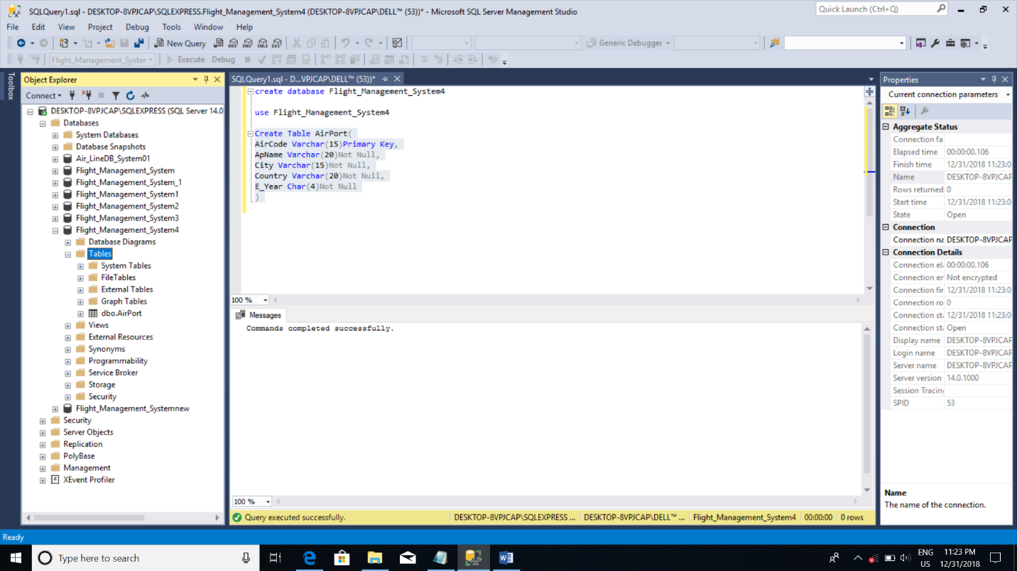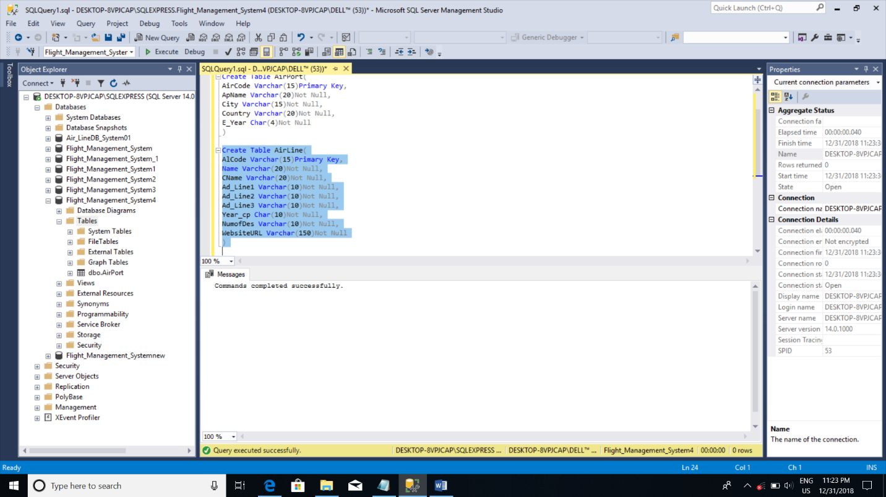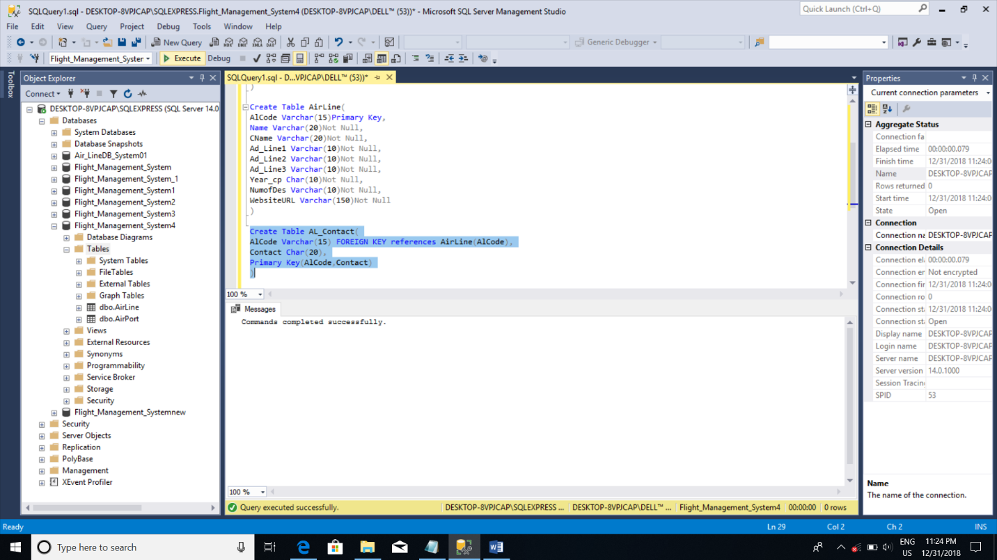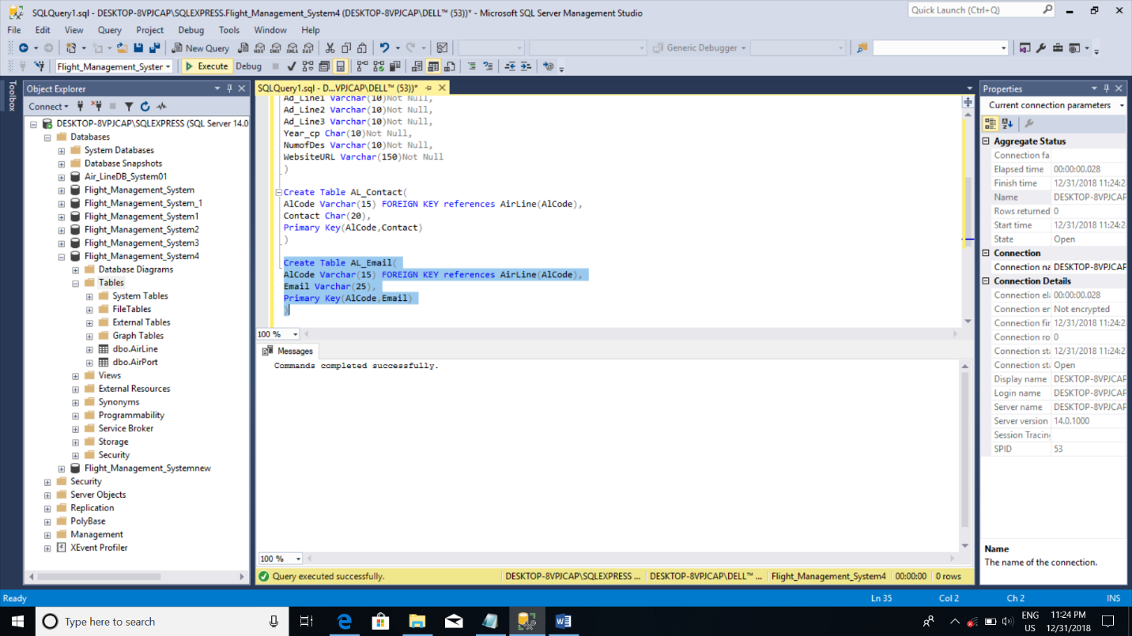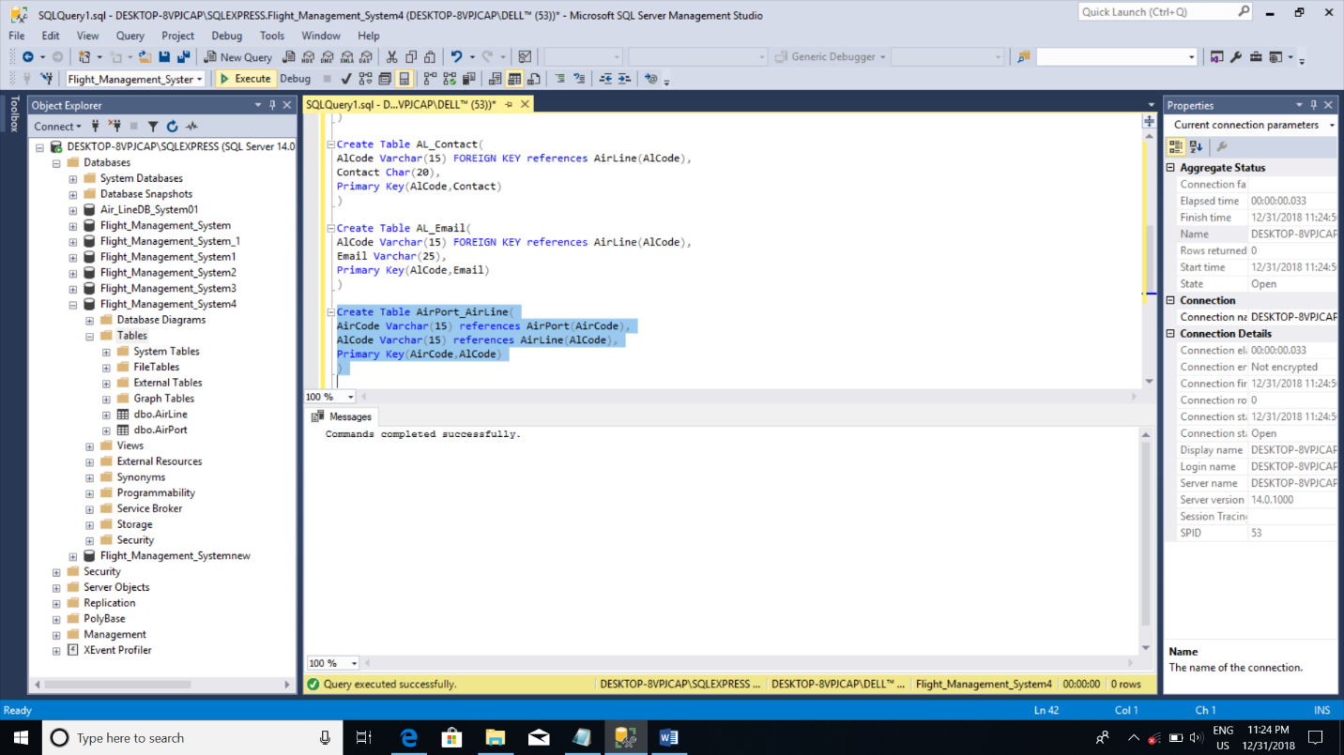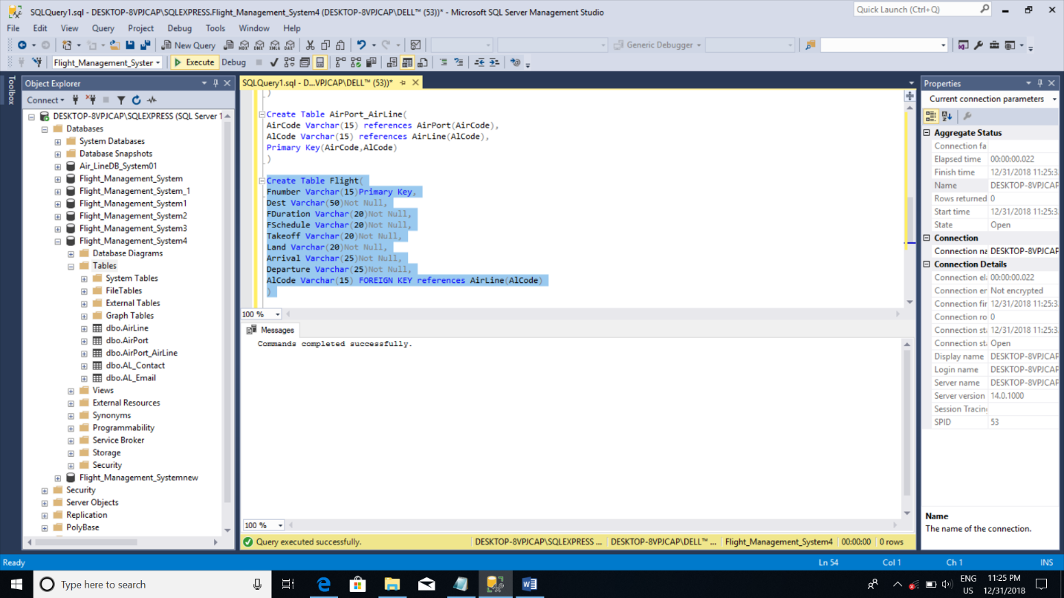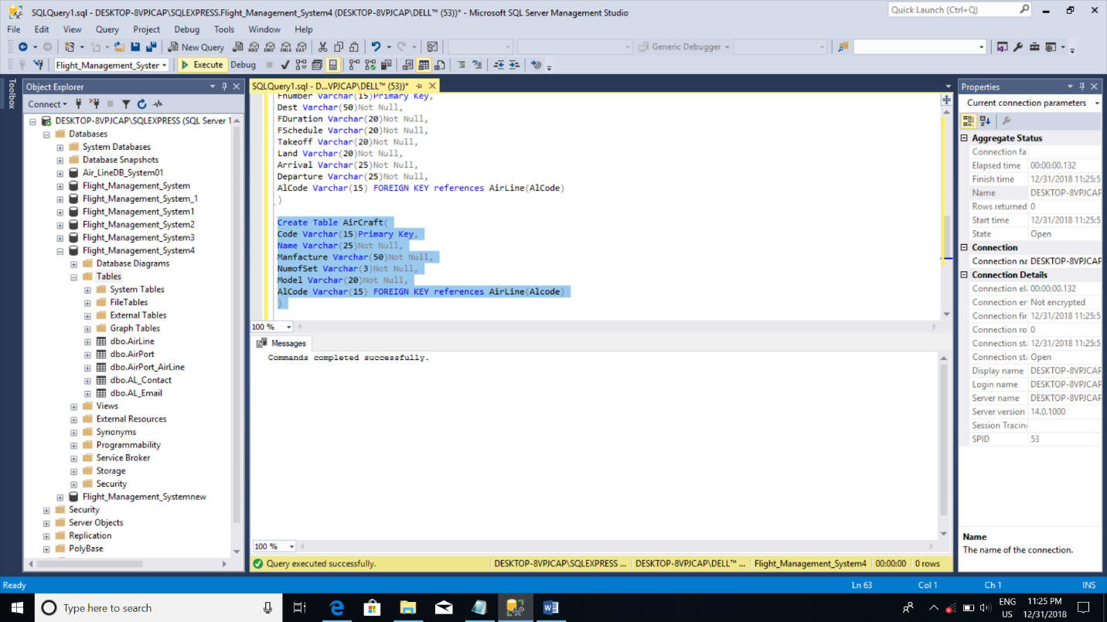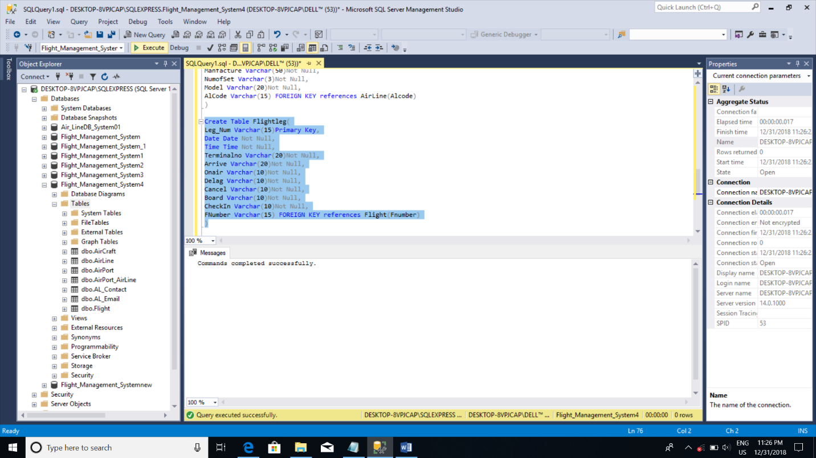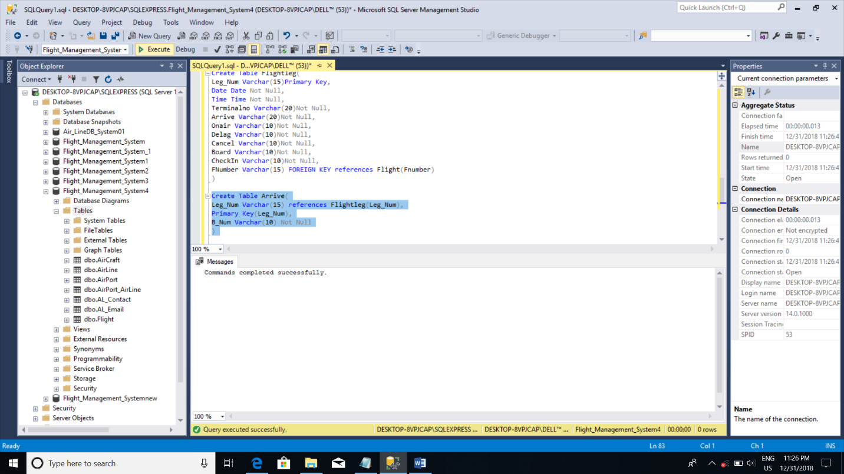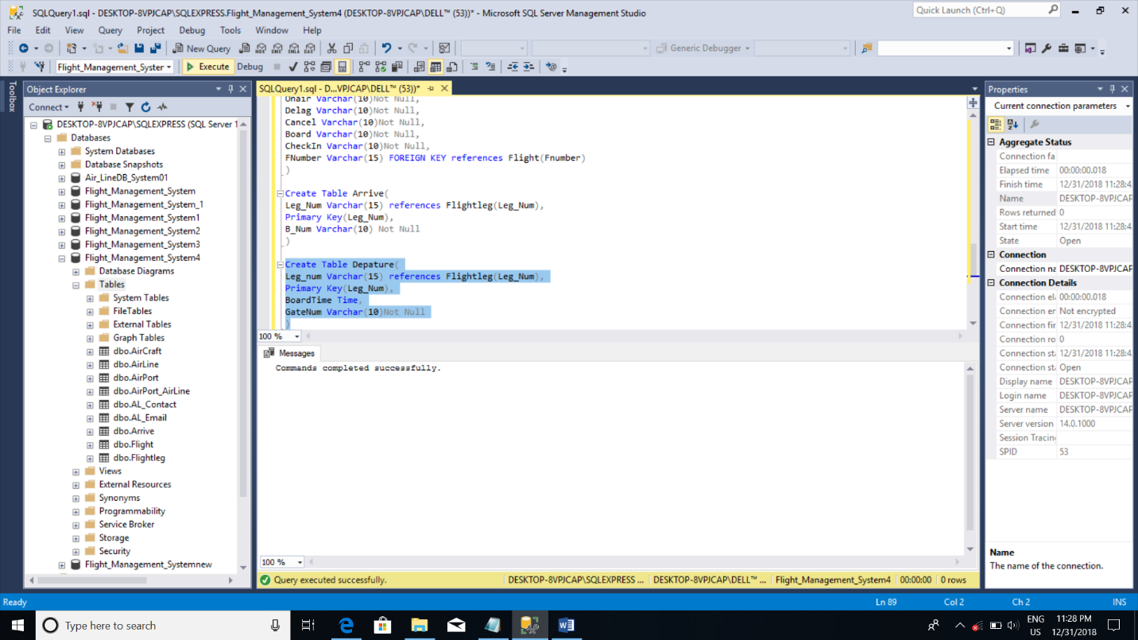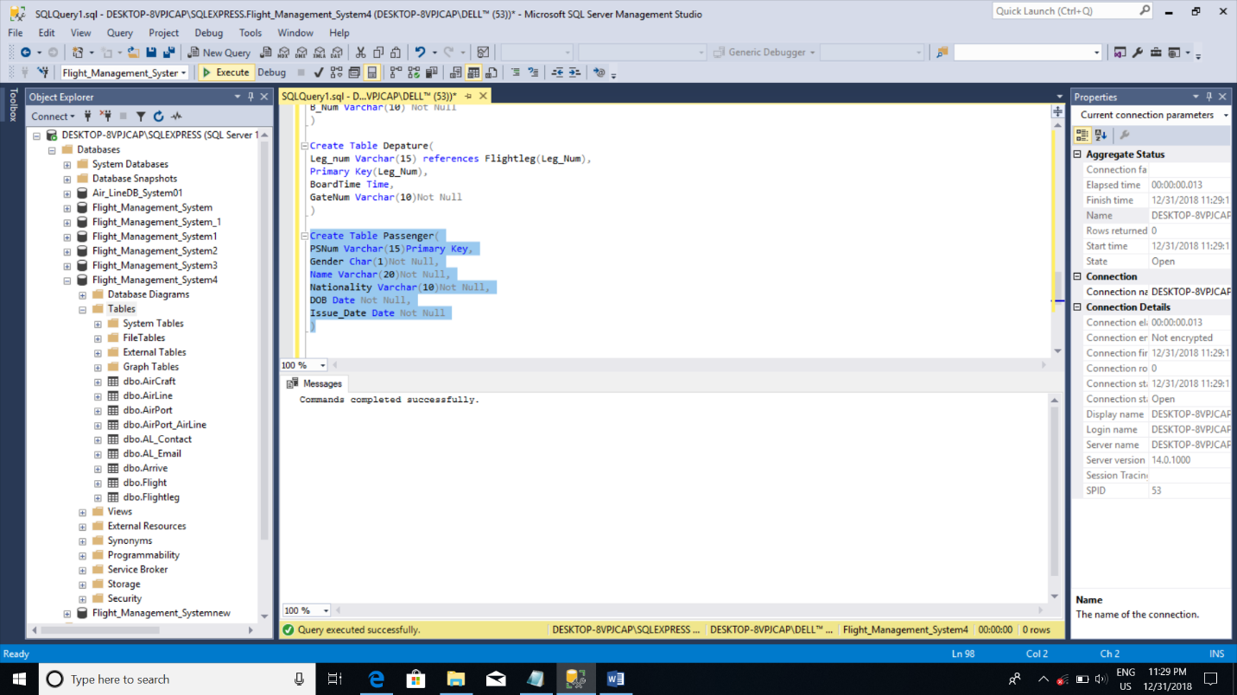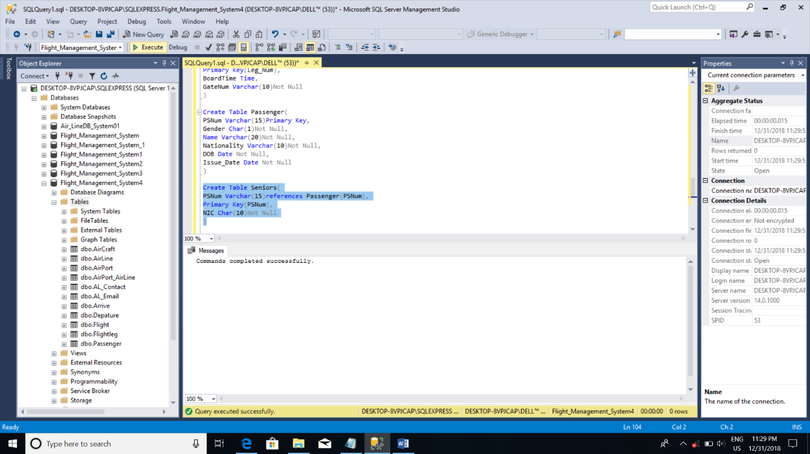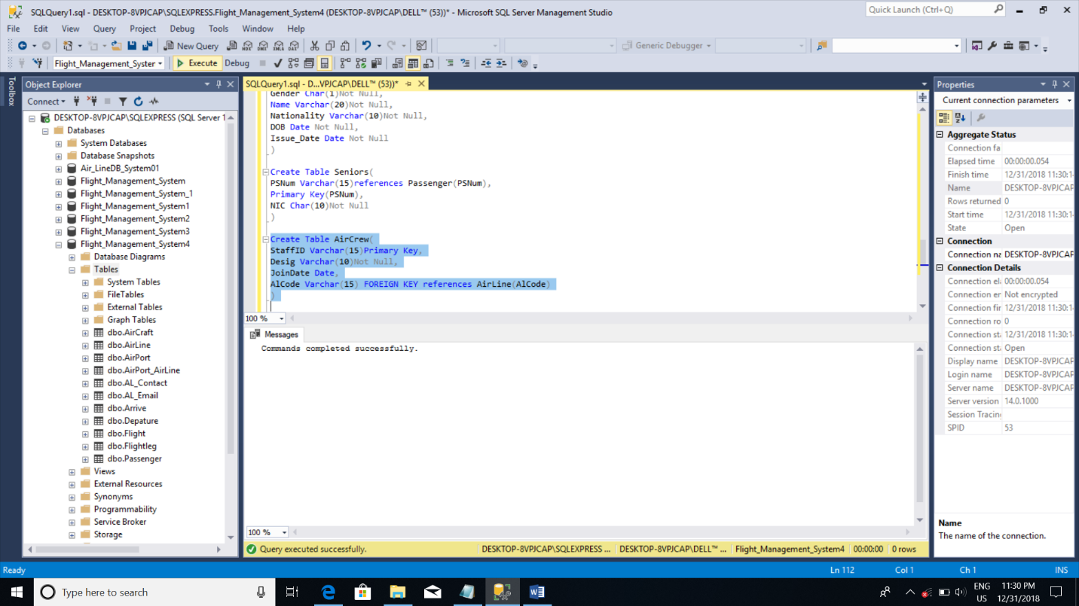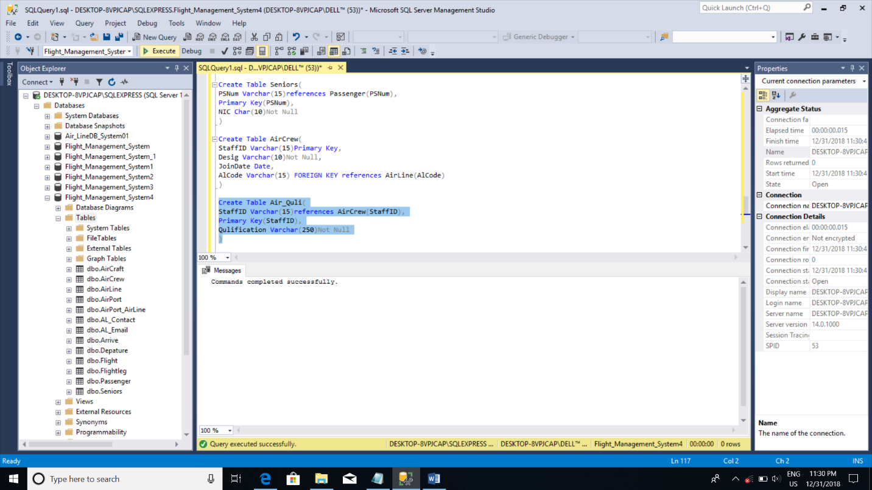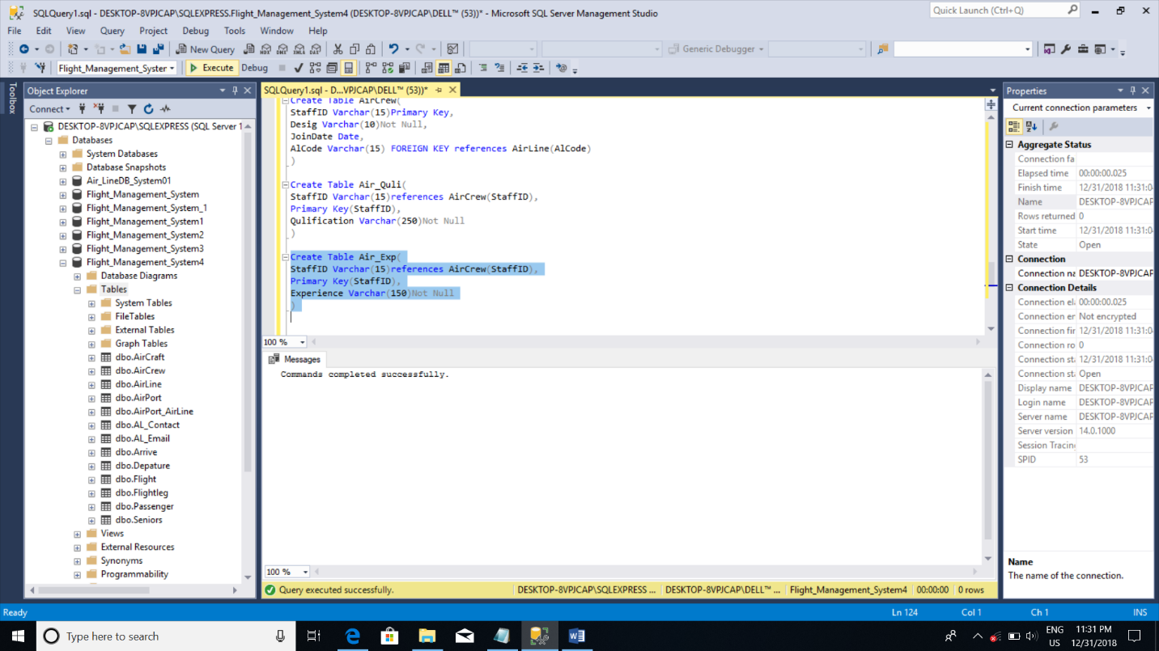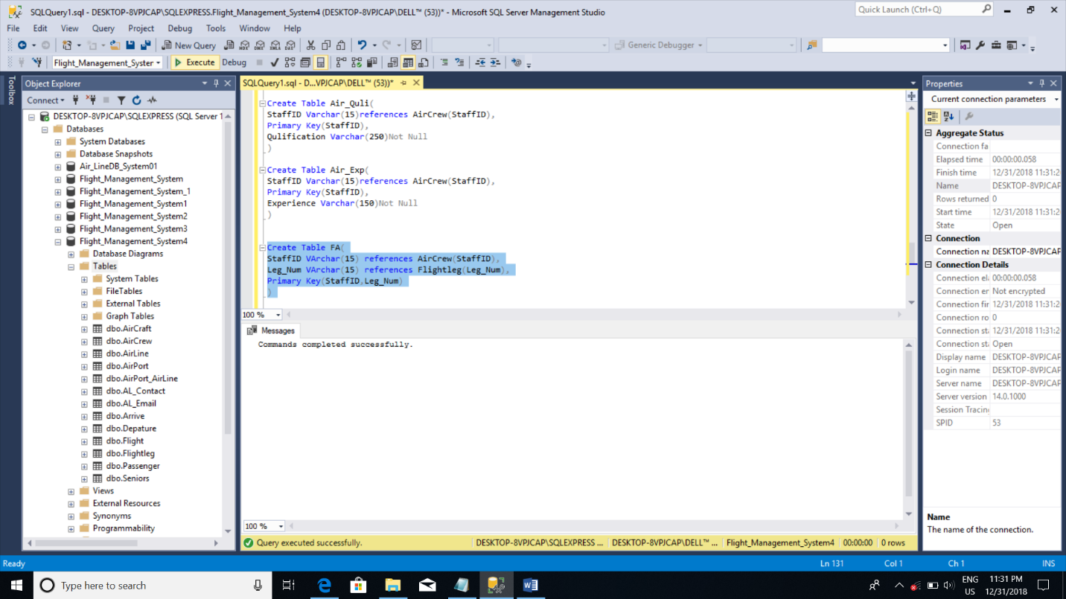

## Database Diagram

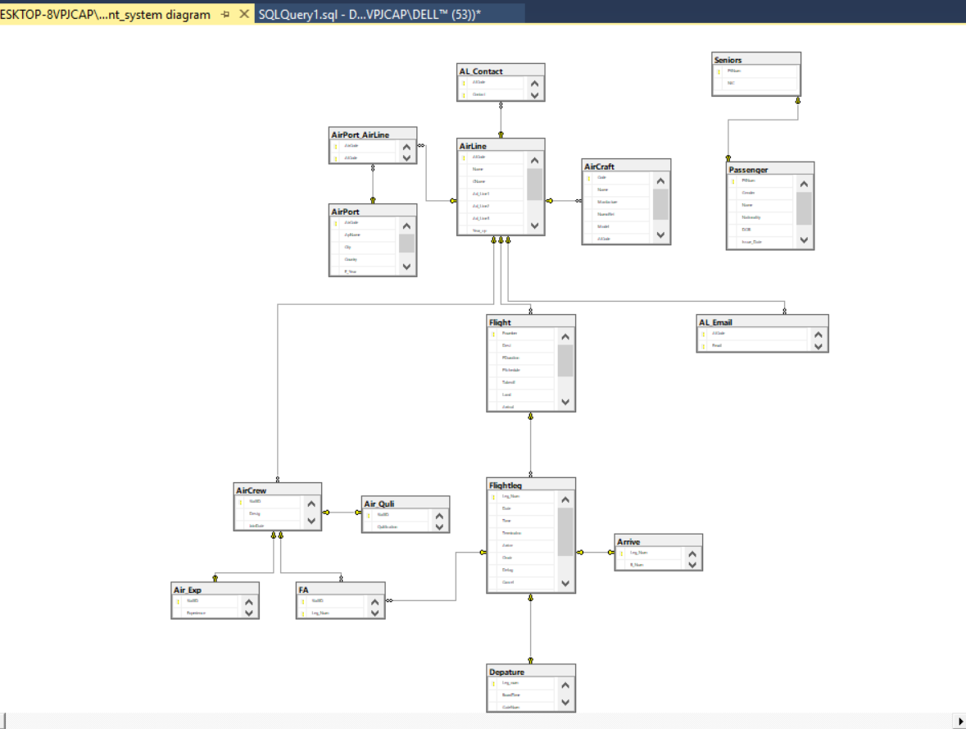

## Sample Records

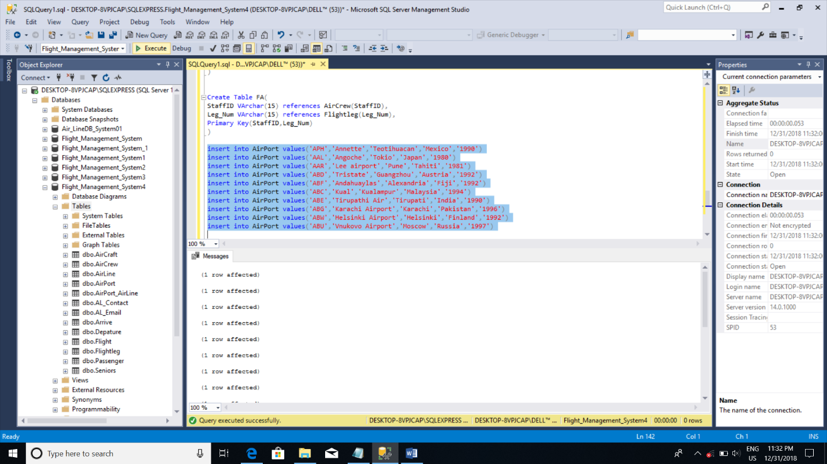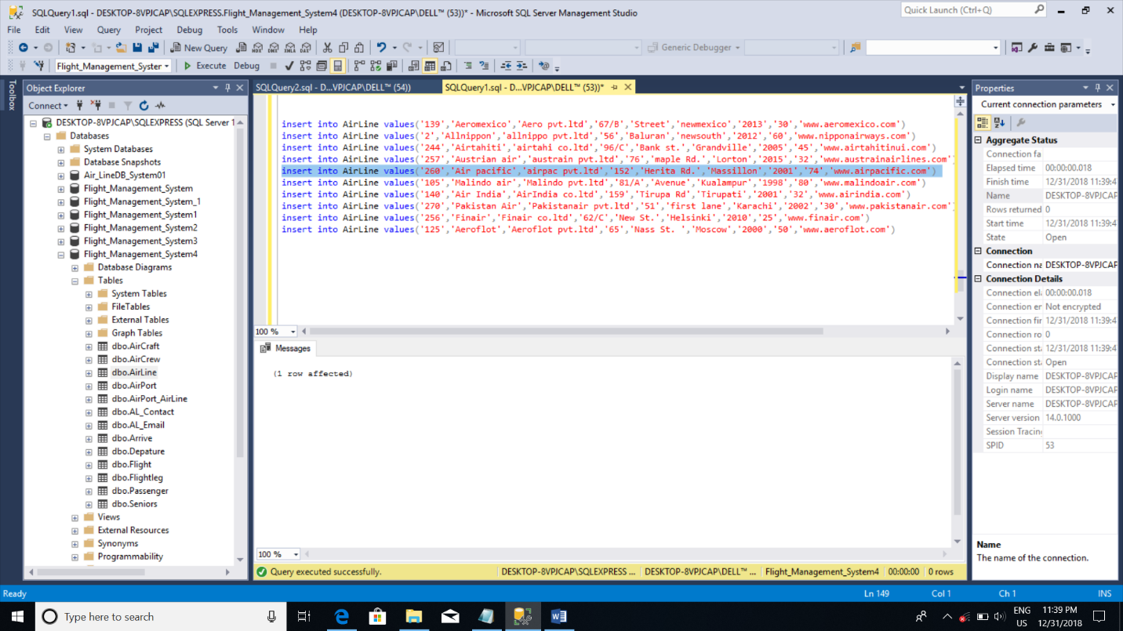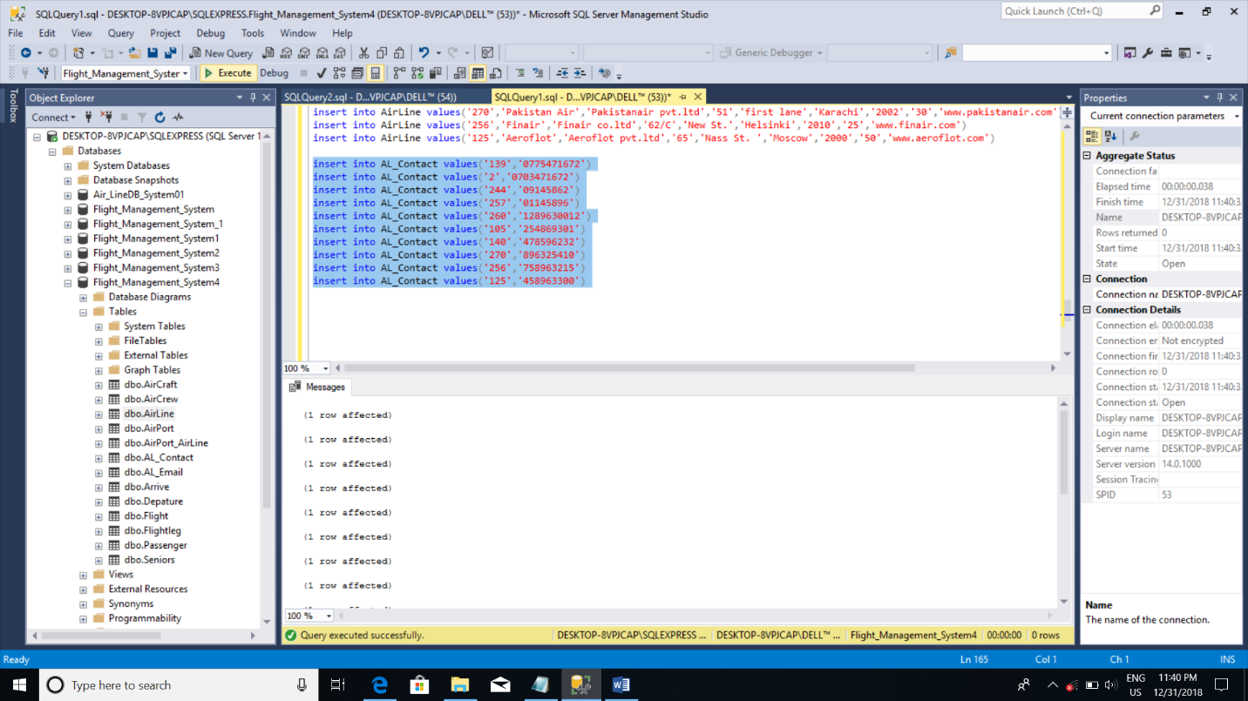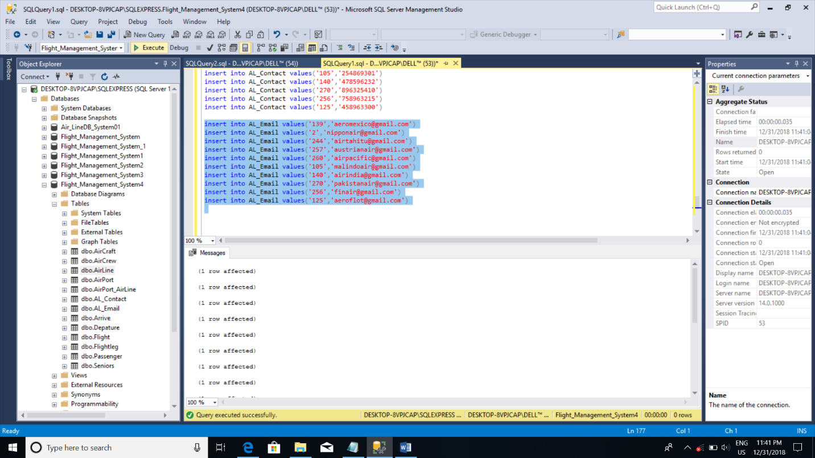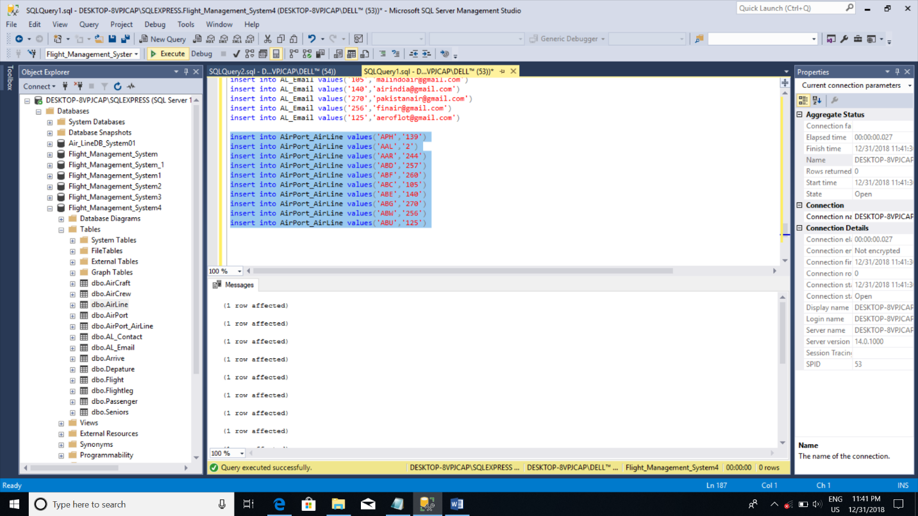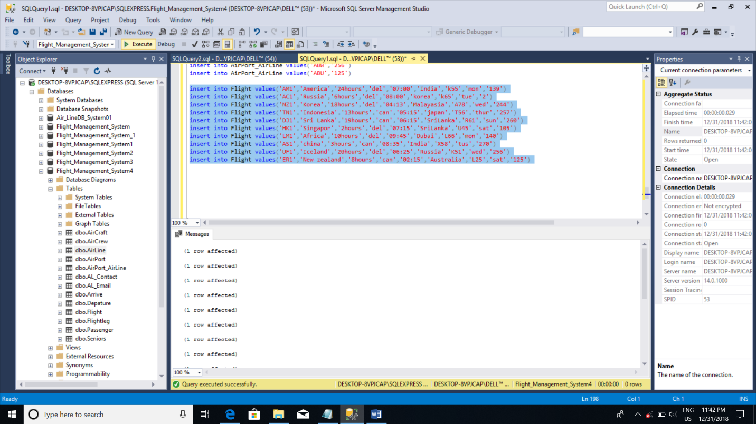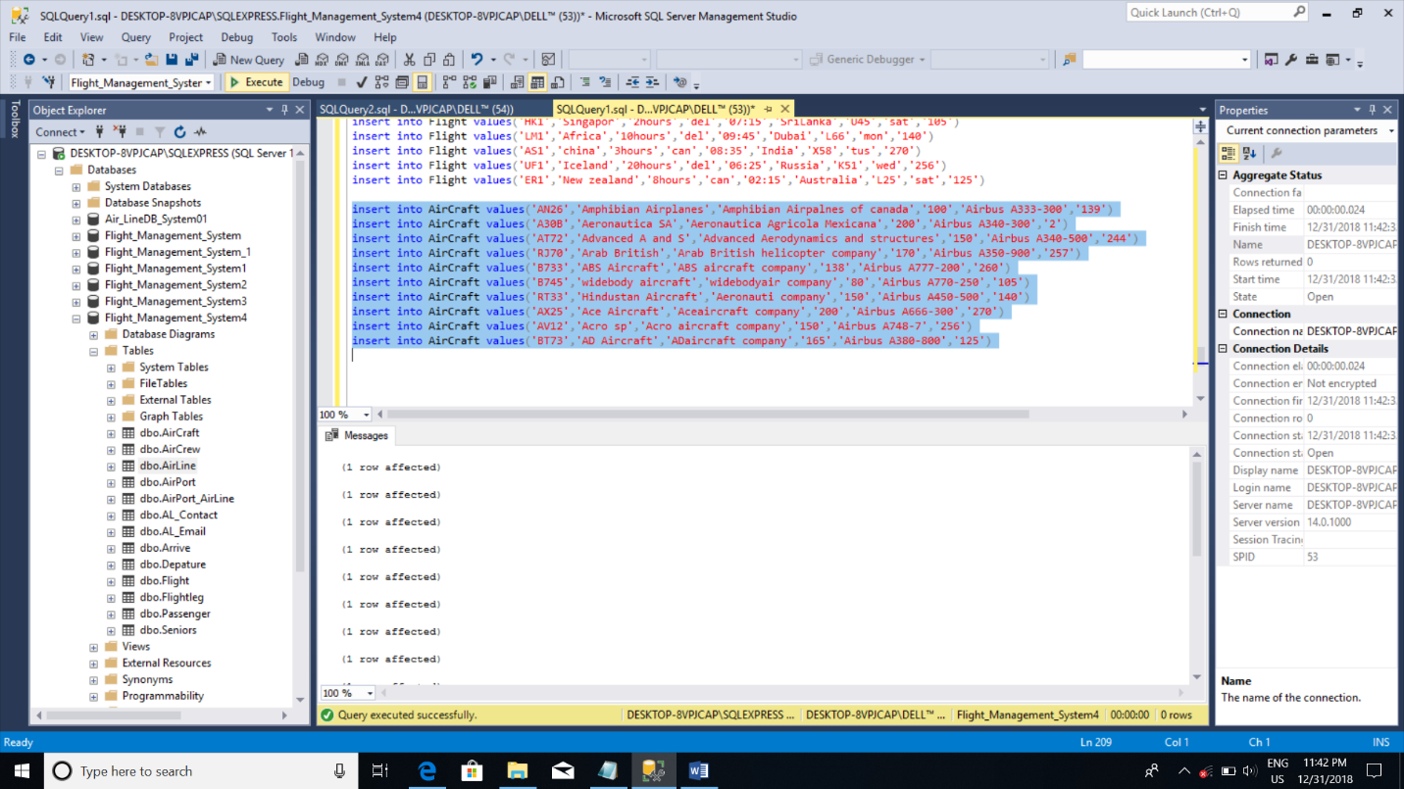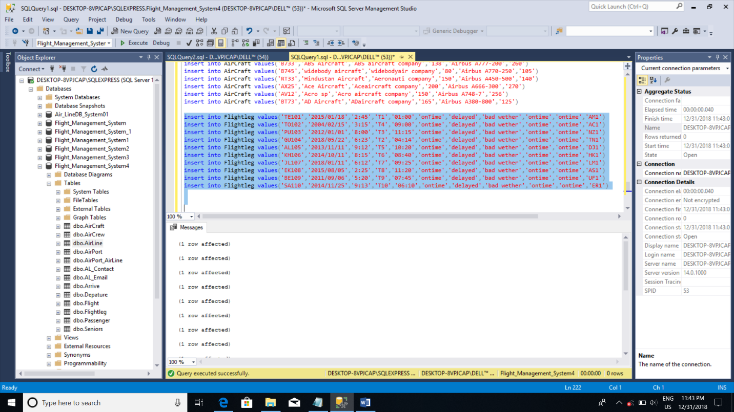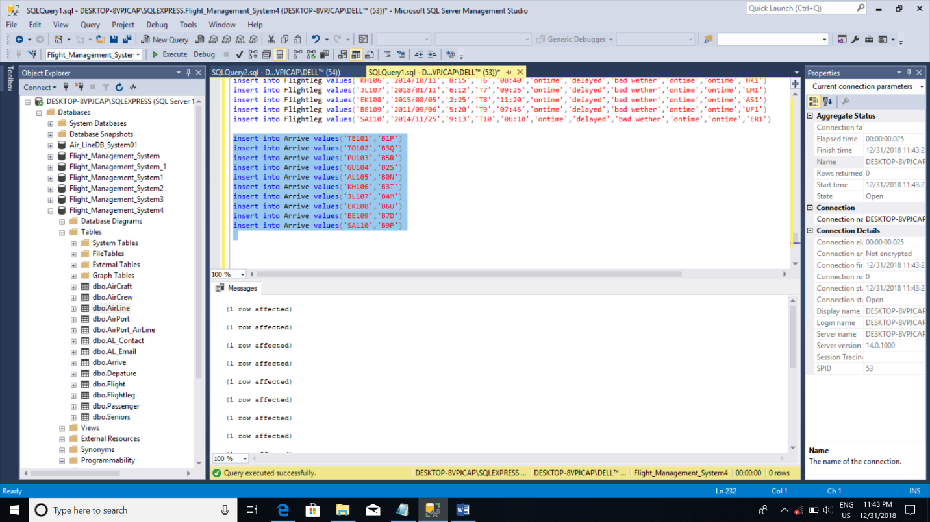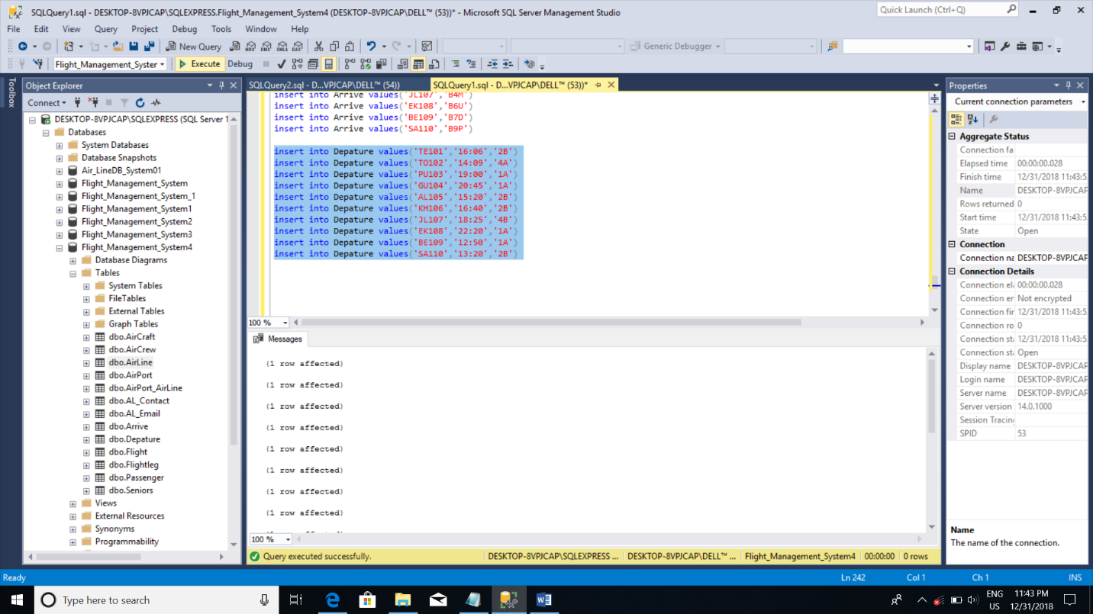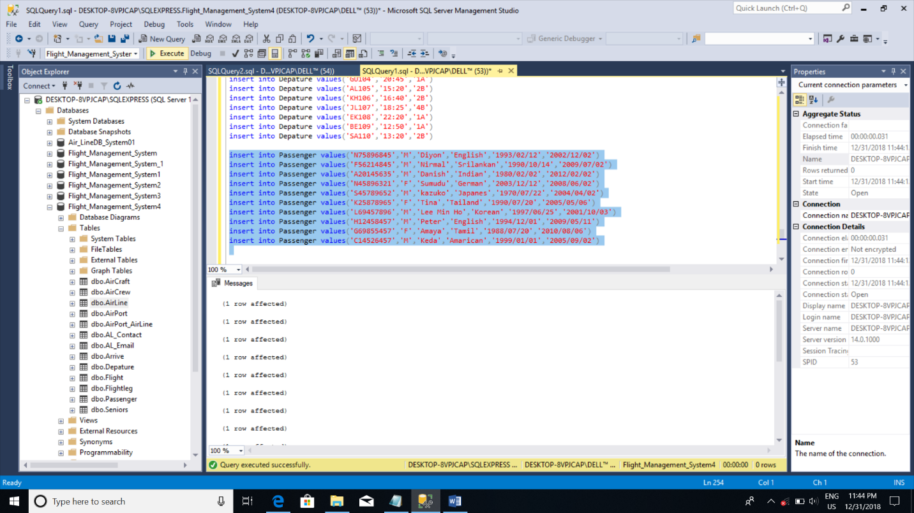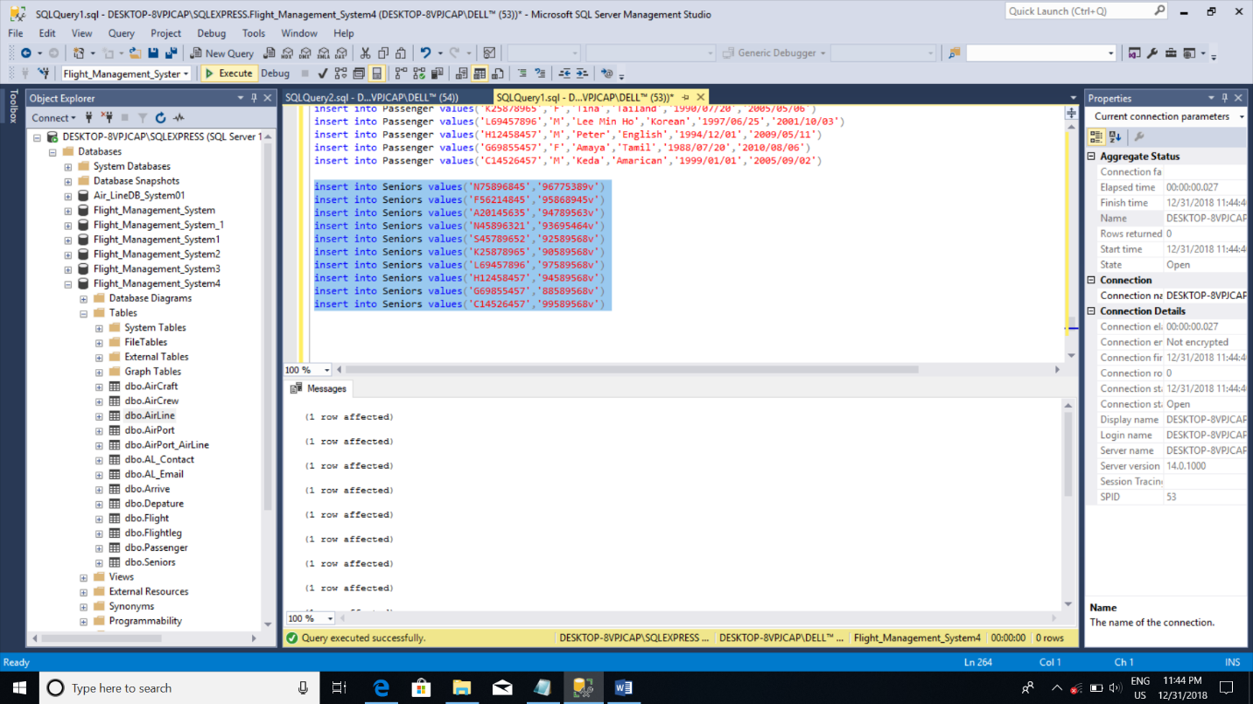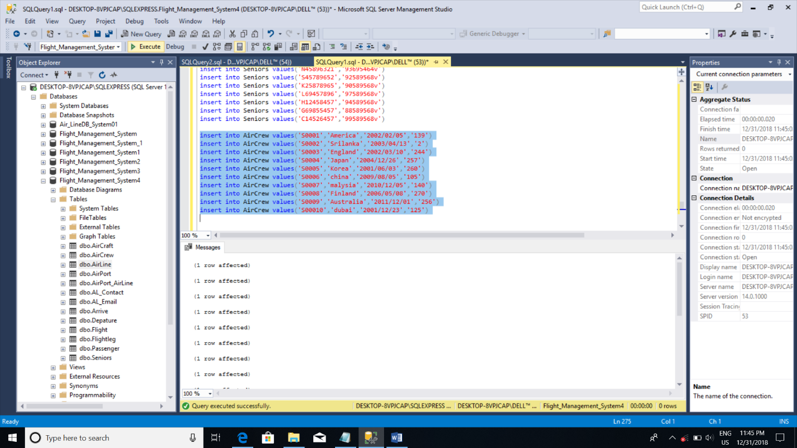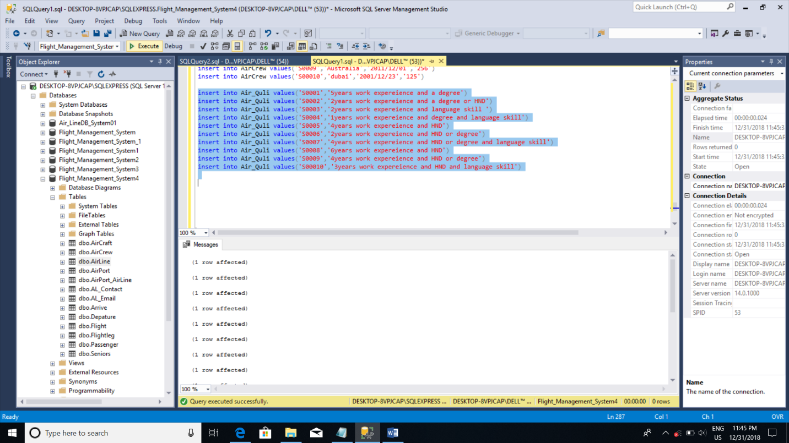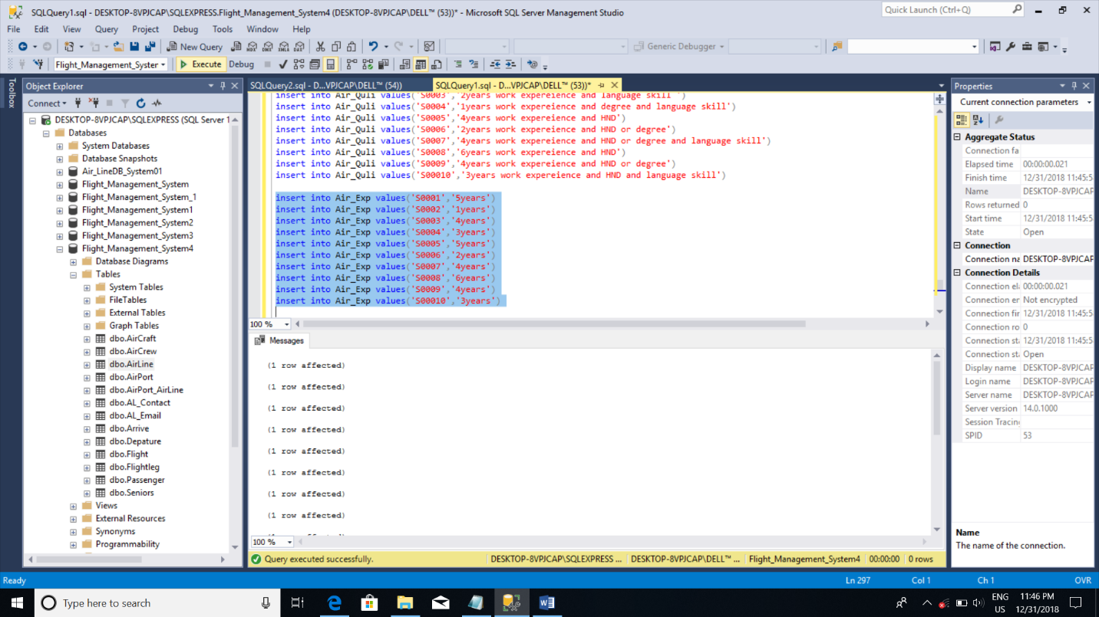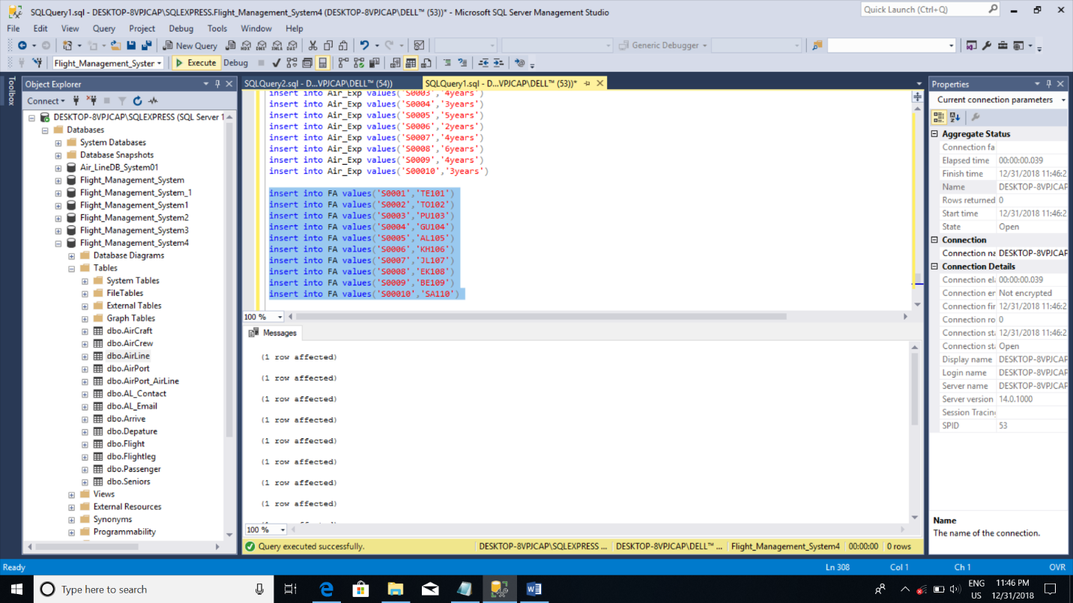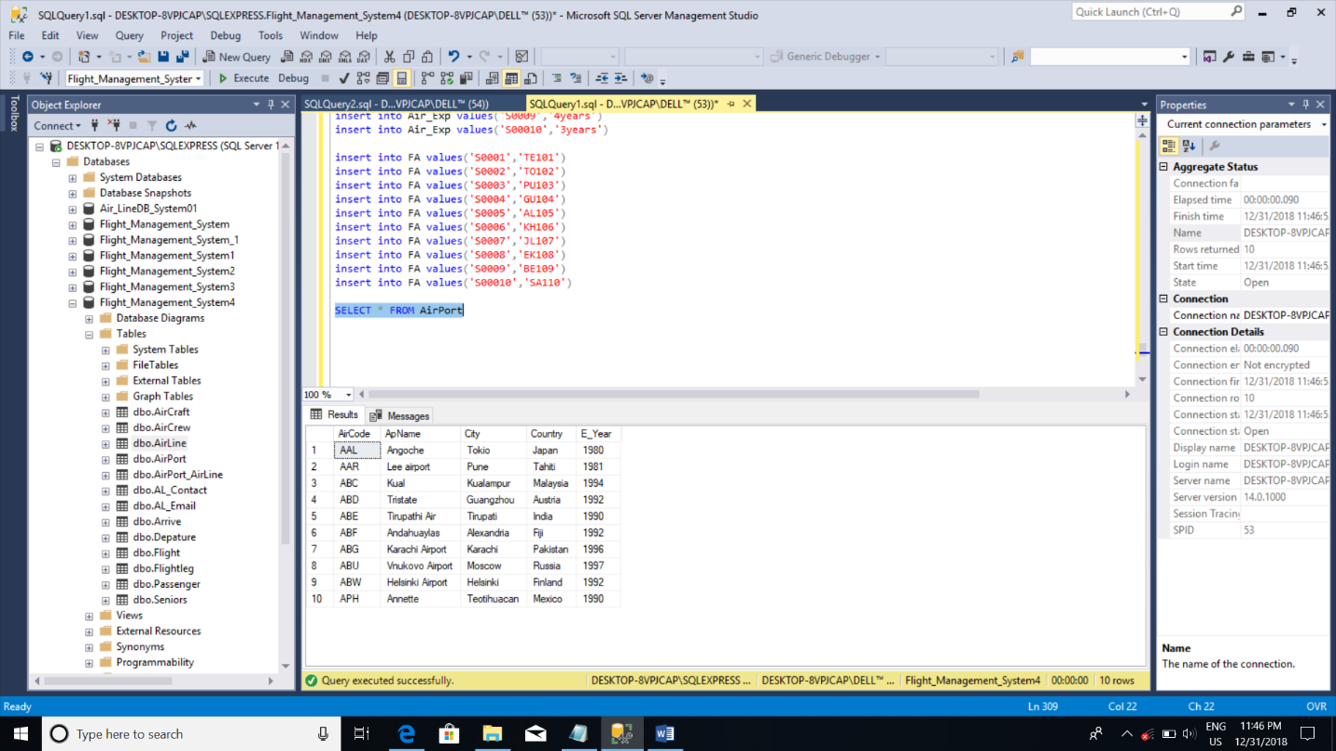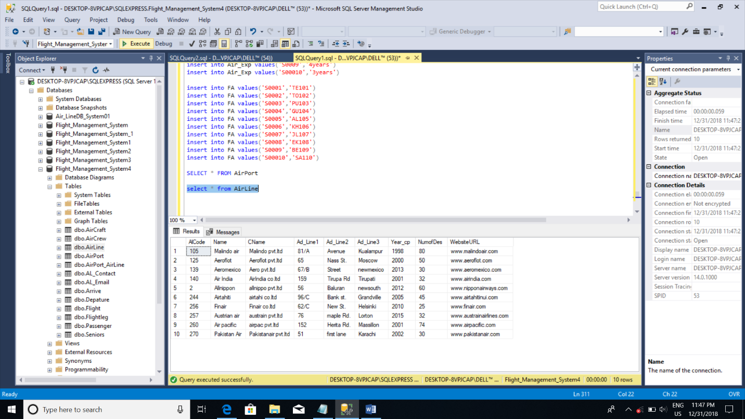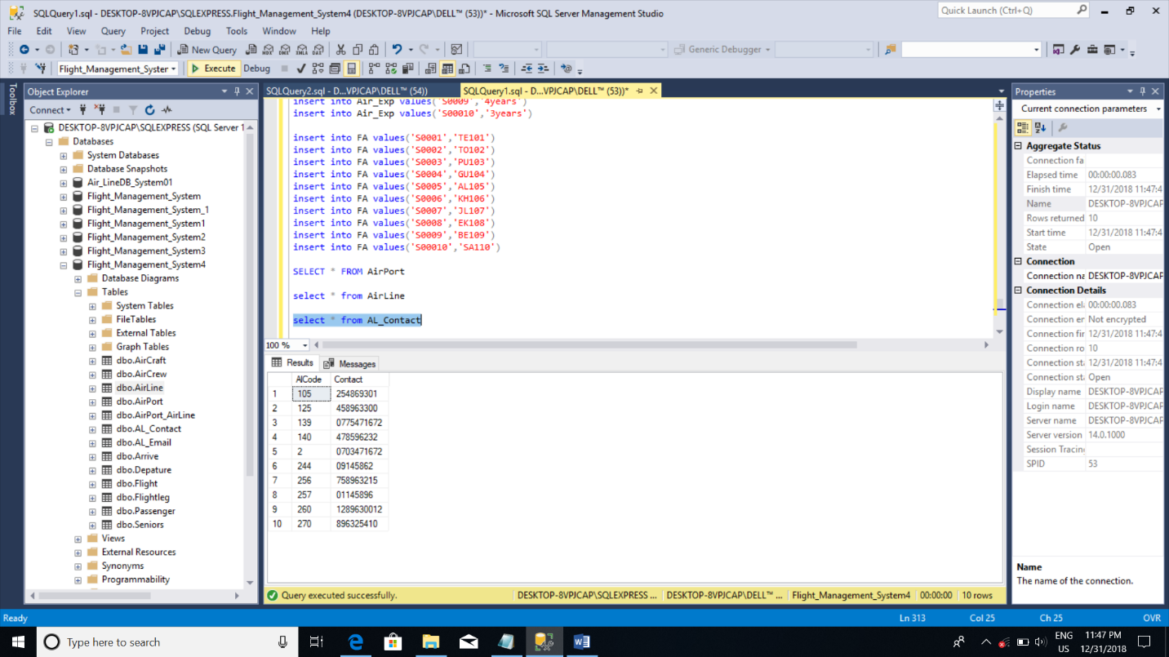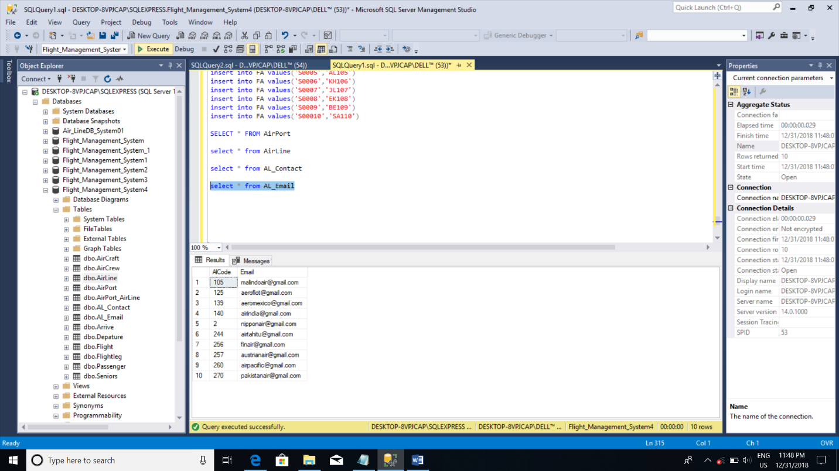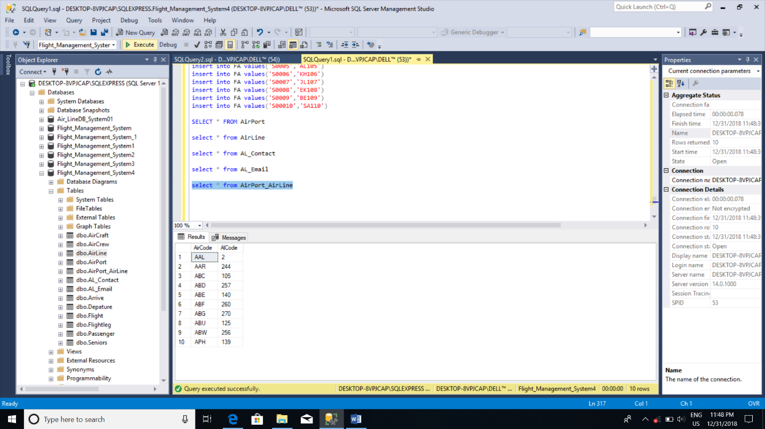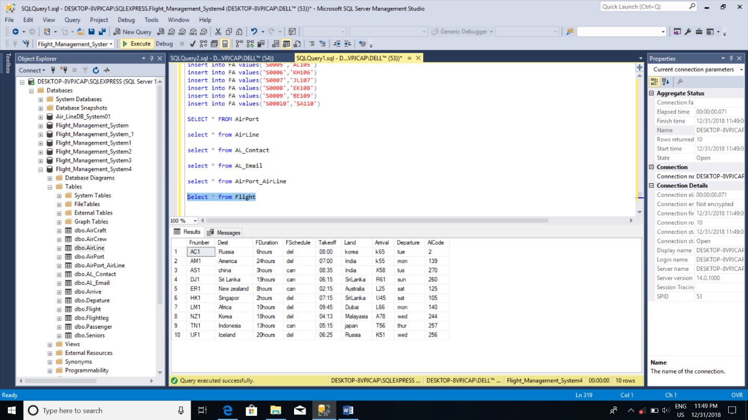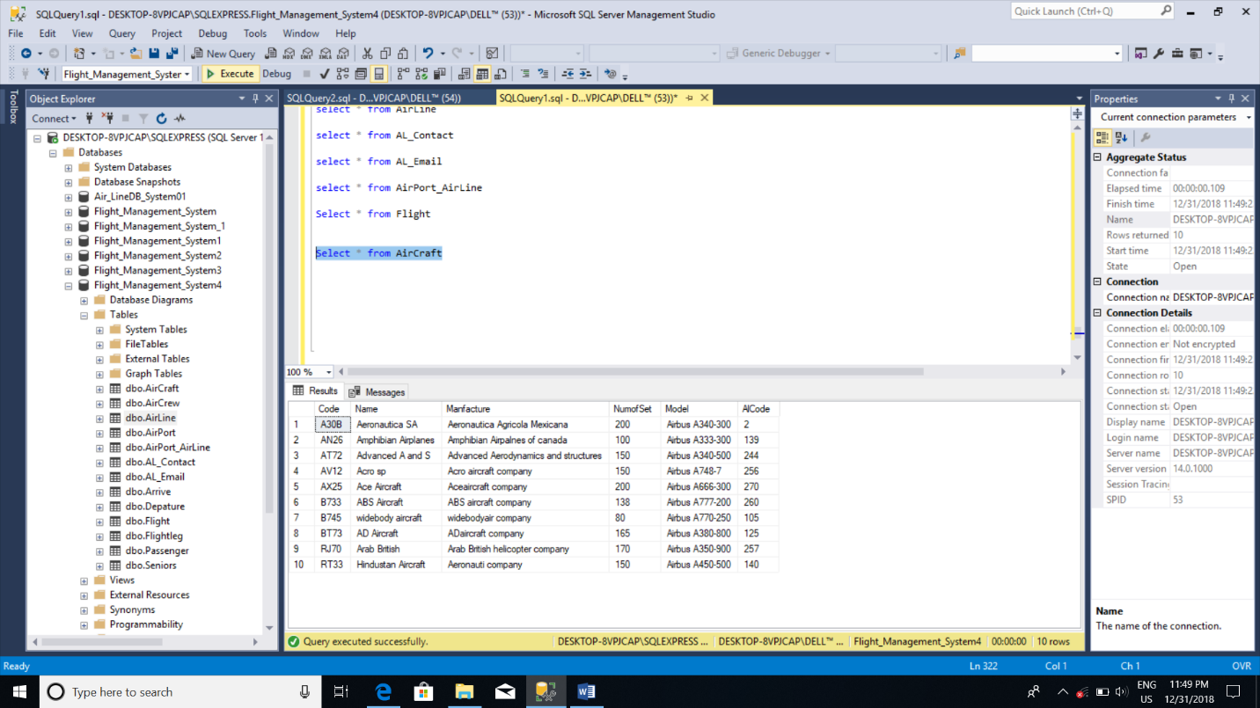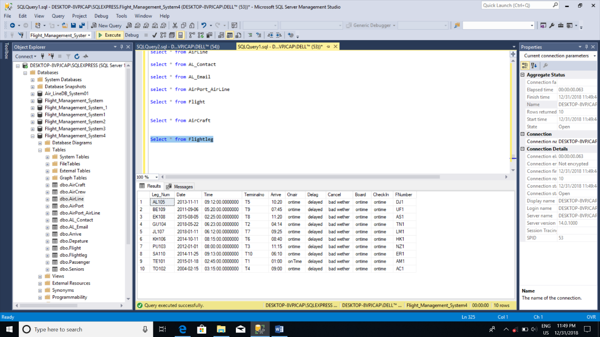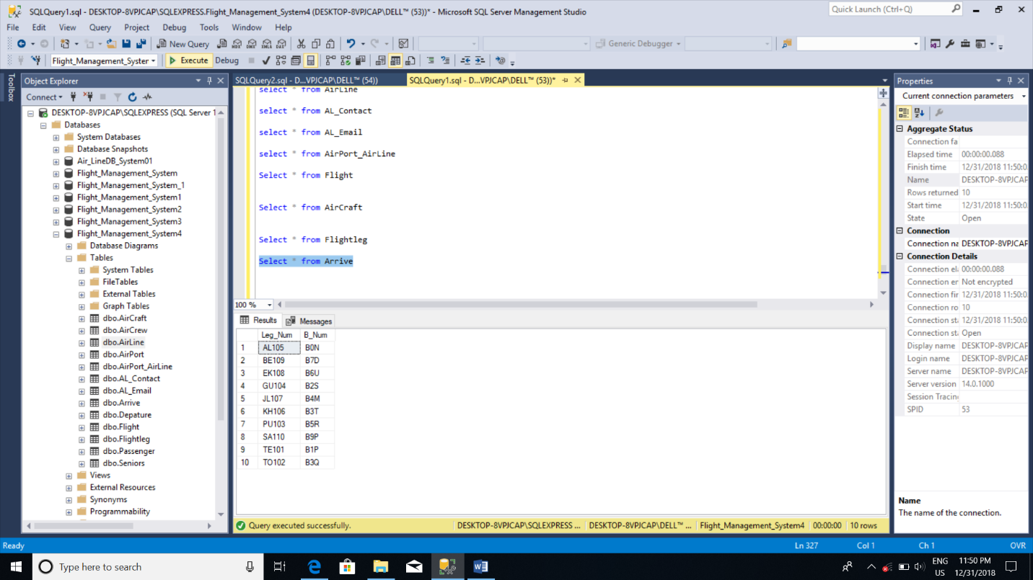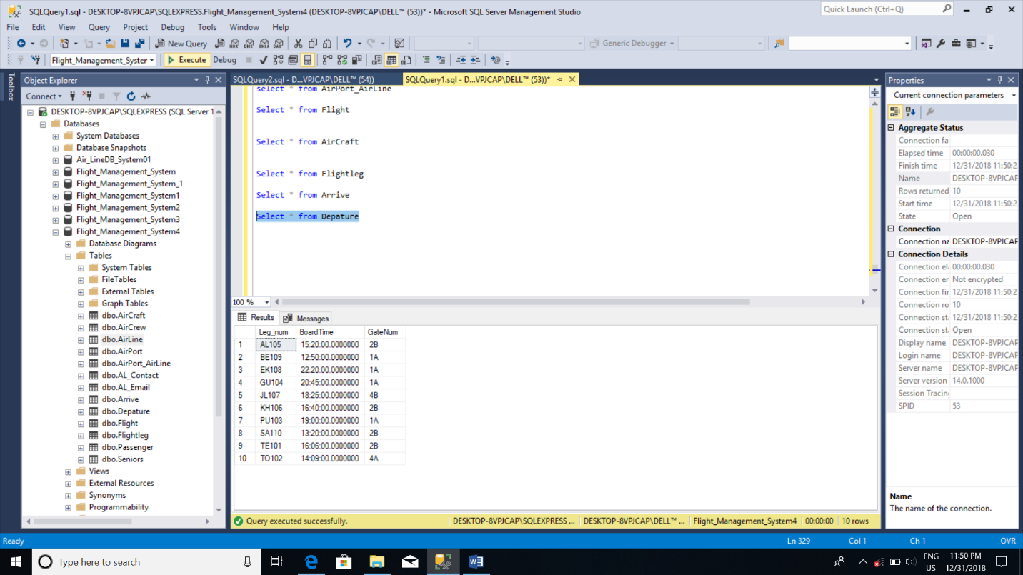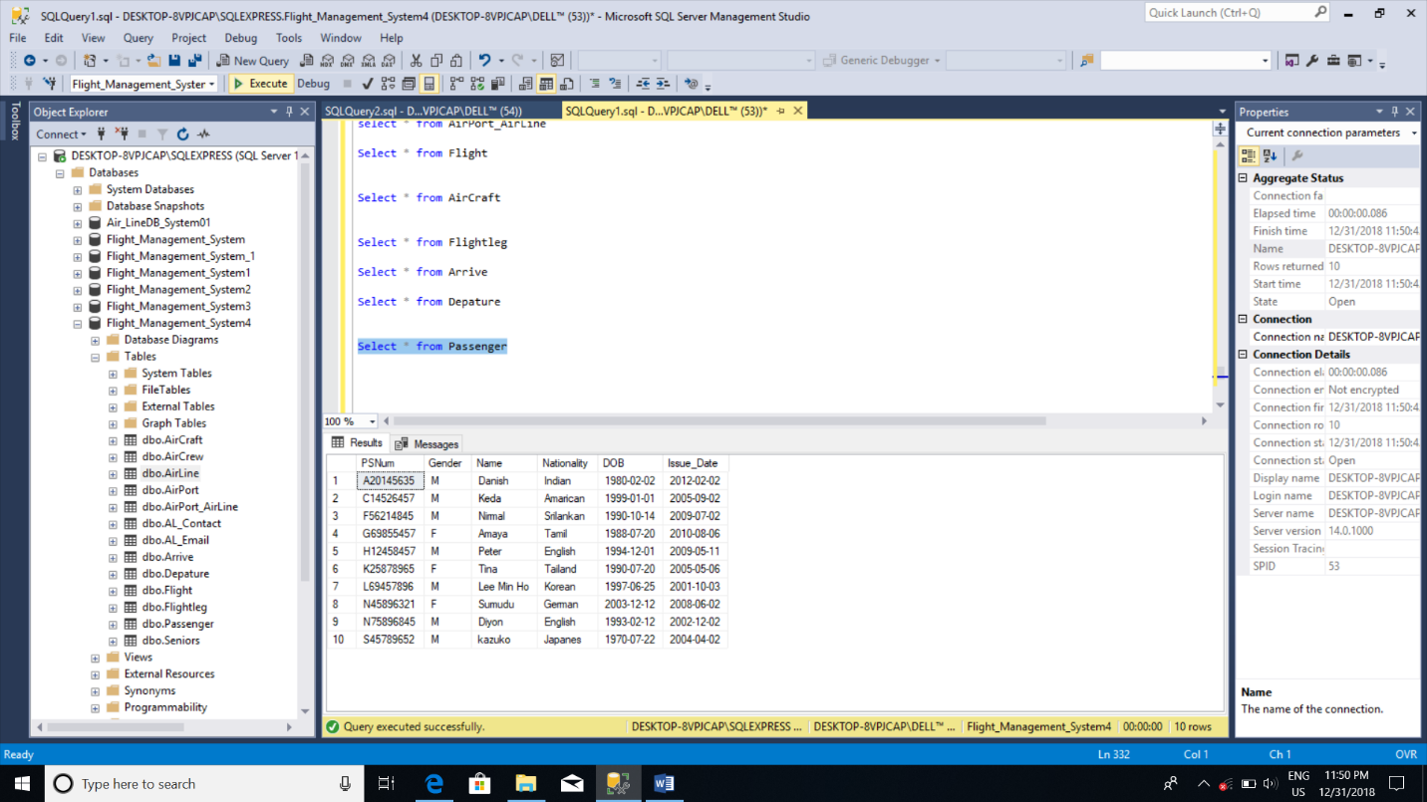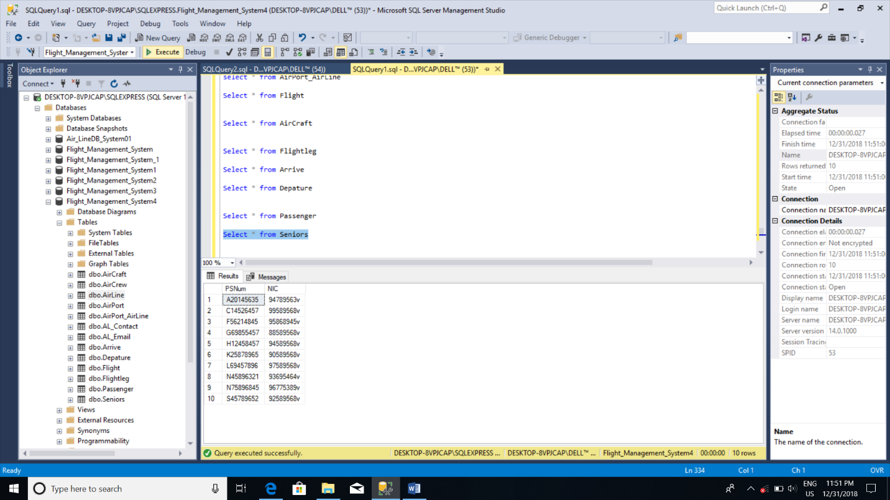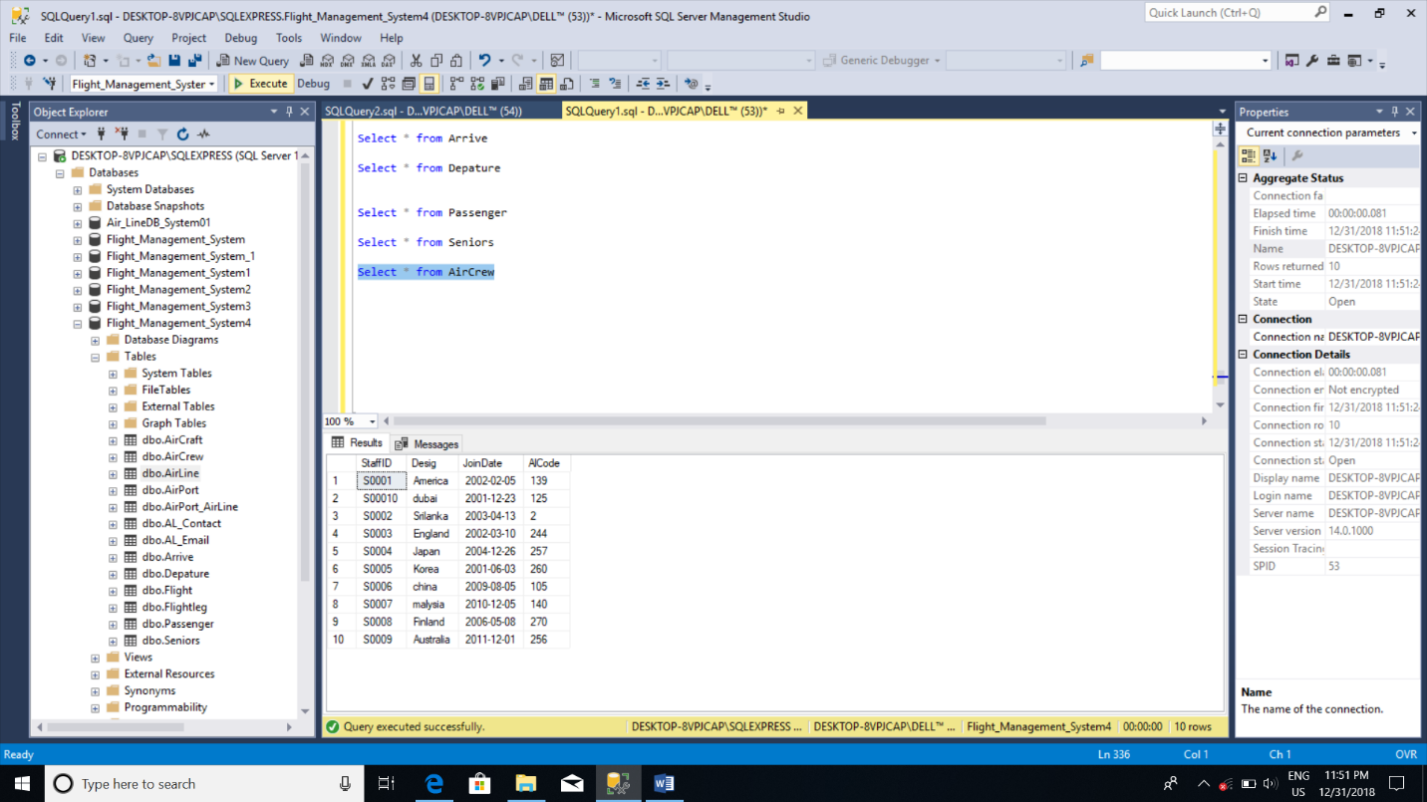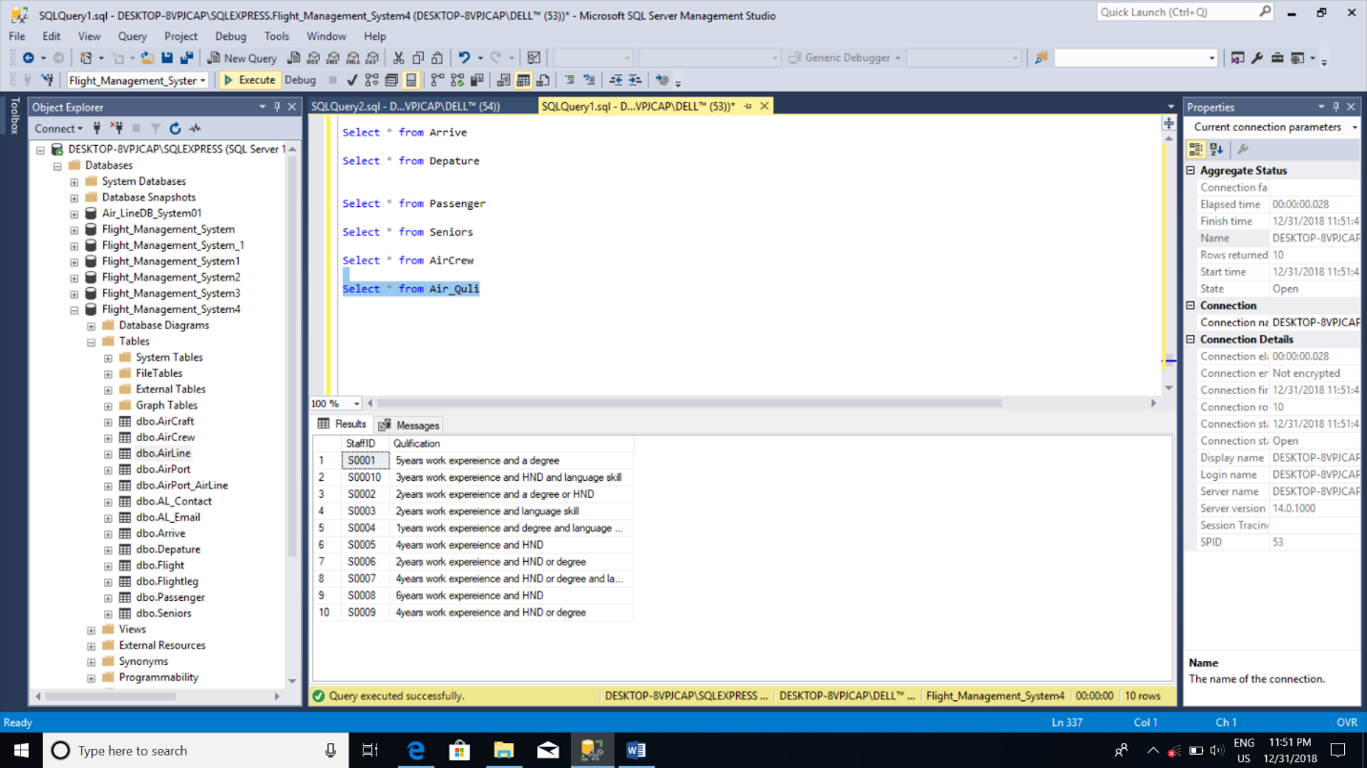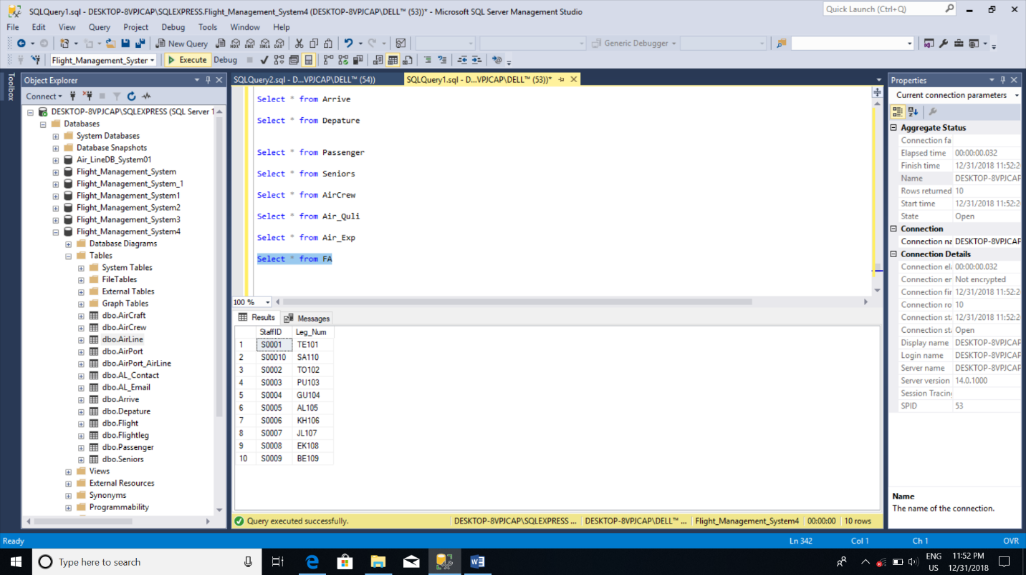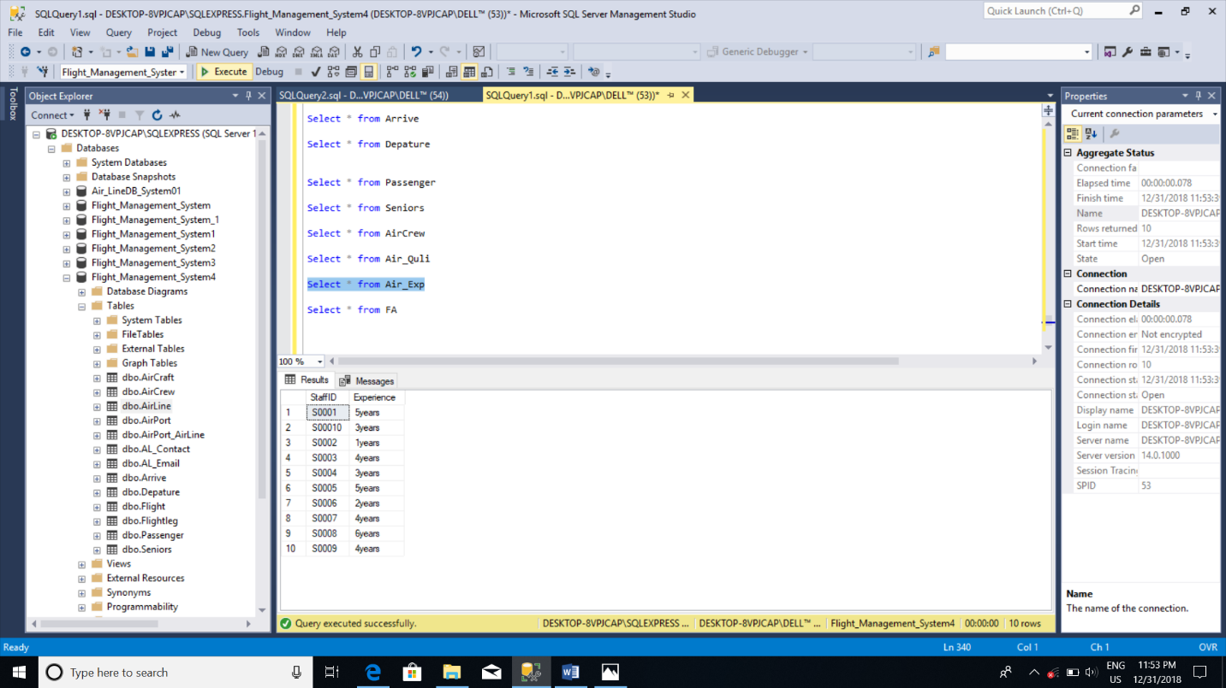

# Section 3

## Microsoft SQL Server Create Trigger Statement

CREATE TABLE AirPort_Modified

(

AirCode varchar(15),

ApName varchar(20),

)

CREATE TRIGGER AirPort_update

ON AirPort

AFTER UPDATE

AS

DECLARE @ApCode varchar(15)

SELECT @ApCode=(select AirCode from inserted)

insert into AirPort_Modified(AirCode,ApName) values (@ApCode,getdate());

PRINT 'Succesfully updated'+@ApCode+'from AirPort'

END

CREATE Trigger insert_Airport

ON AirPort

AFTER INSERT

AS

DECLARE @ApCode varchar(15)

DECLARE @AirName varchar(20)

SELECT @ApCode=(select AirCode from inserted)

SELECT @AirName=(select ApName from inserted)

insert into AirPort_Modified(AirCode,ApName) values (@ApCode,getdate());

PRINT 'Succesfully inserted'+@ApCode+'from AirPort'

PRINT 'Succesfully inserted'+@AirName+'from AirPort'

END

CREATE TRIGGER AirPort_Delete

ON AirPort

AFTER DELETE

AS

DECLARE @ApCode varchar(15)

SELECT @ApCode=(select AirCode from deleted)

insert into AirPort_Modified(AirCode) values ('Delete'+@ApCode+'from AirPort table on'+getdate());

PRINT 'Successfully deleted'+@ApCode+'from AirPort'

END

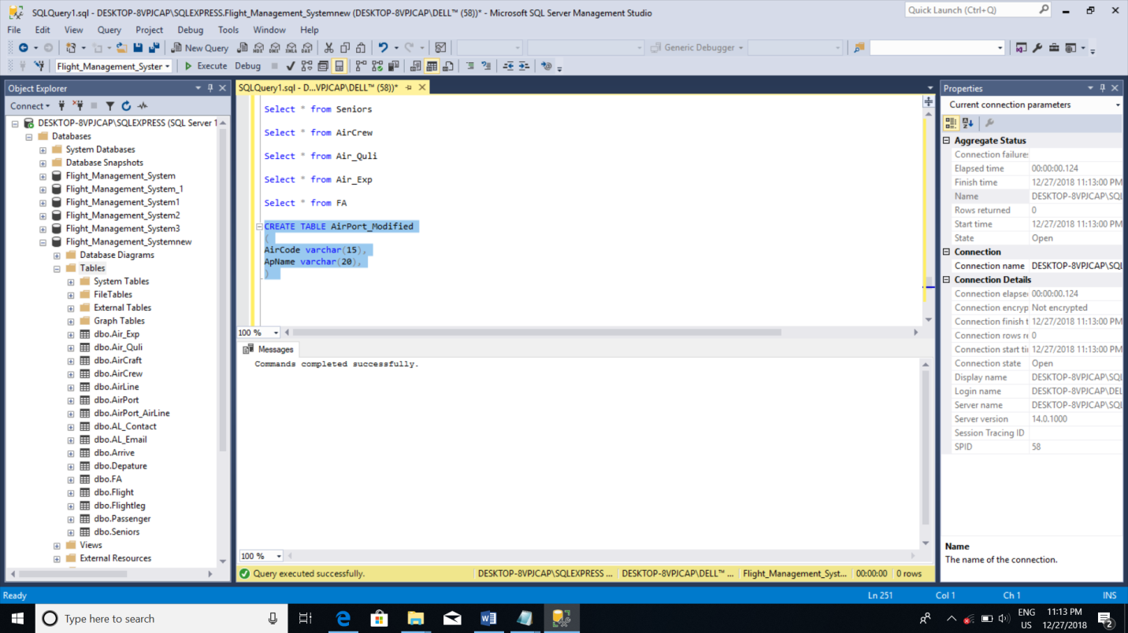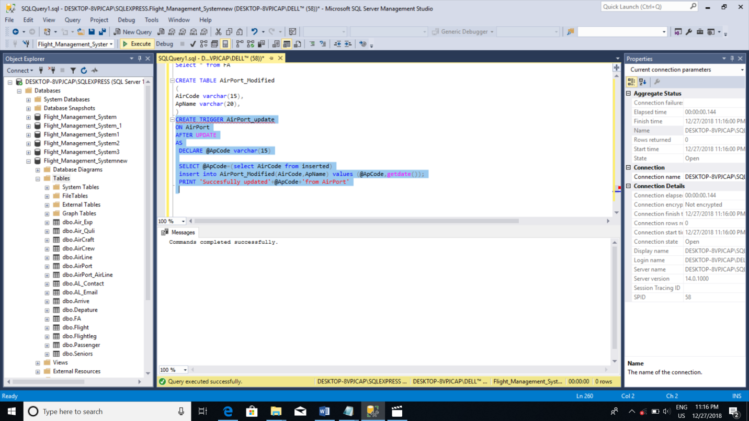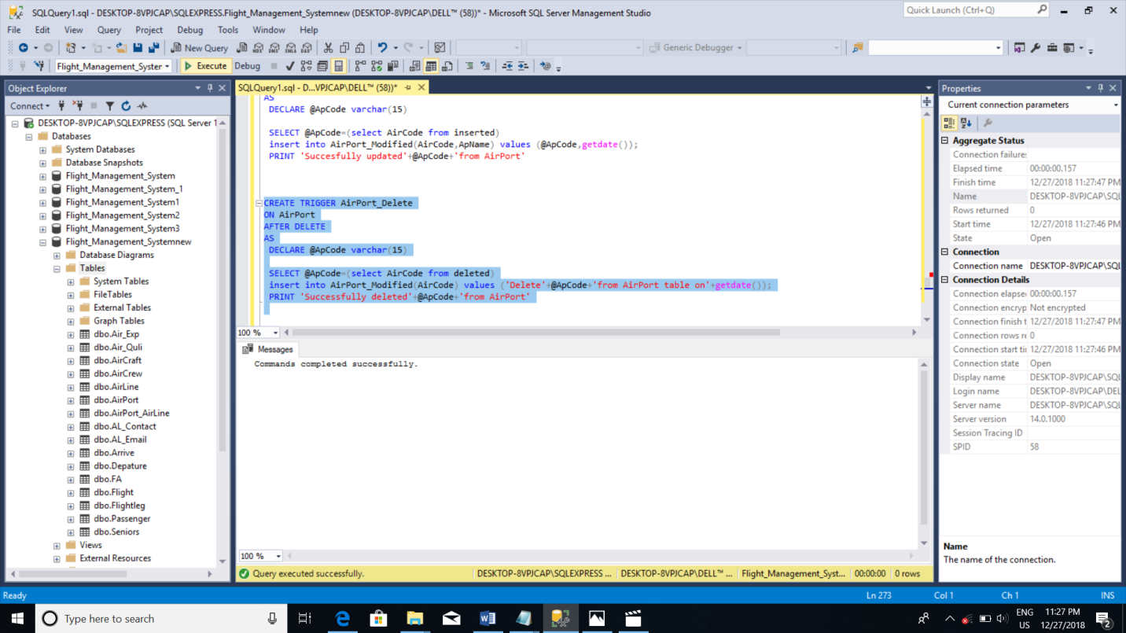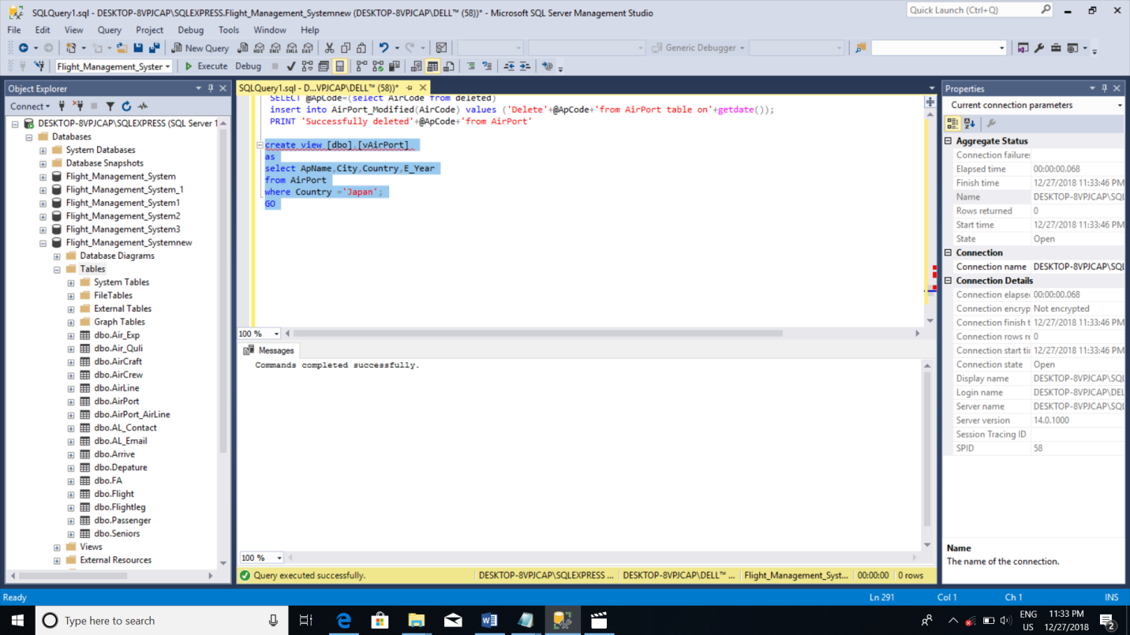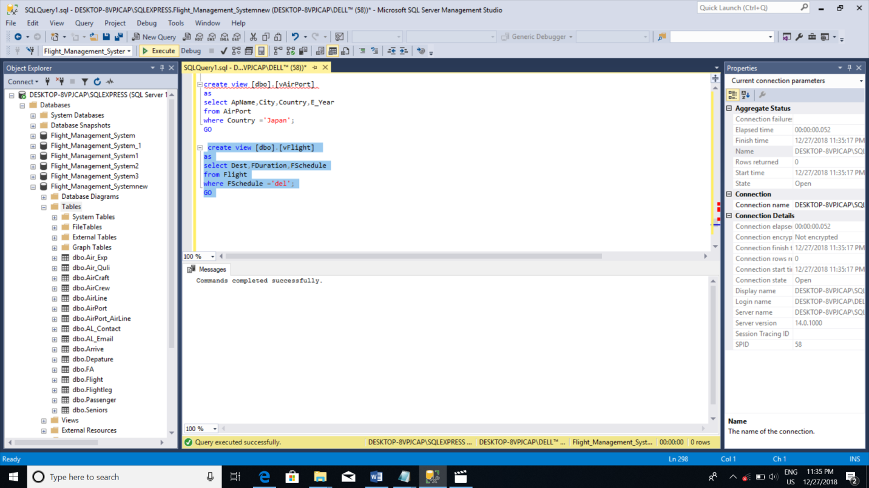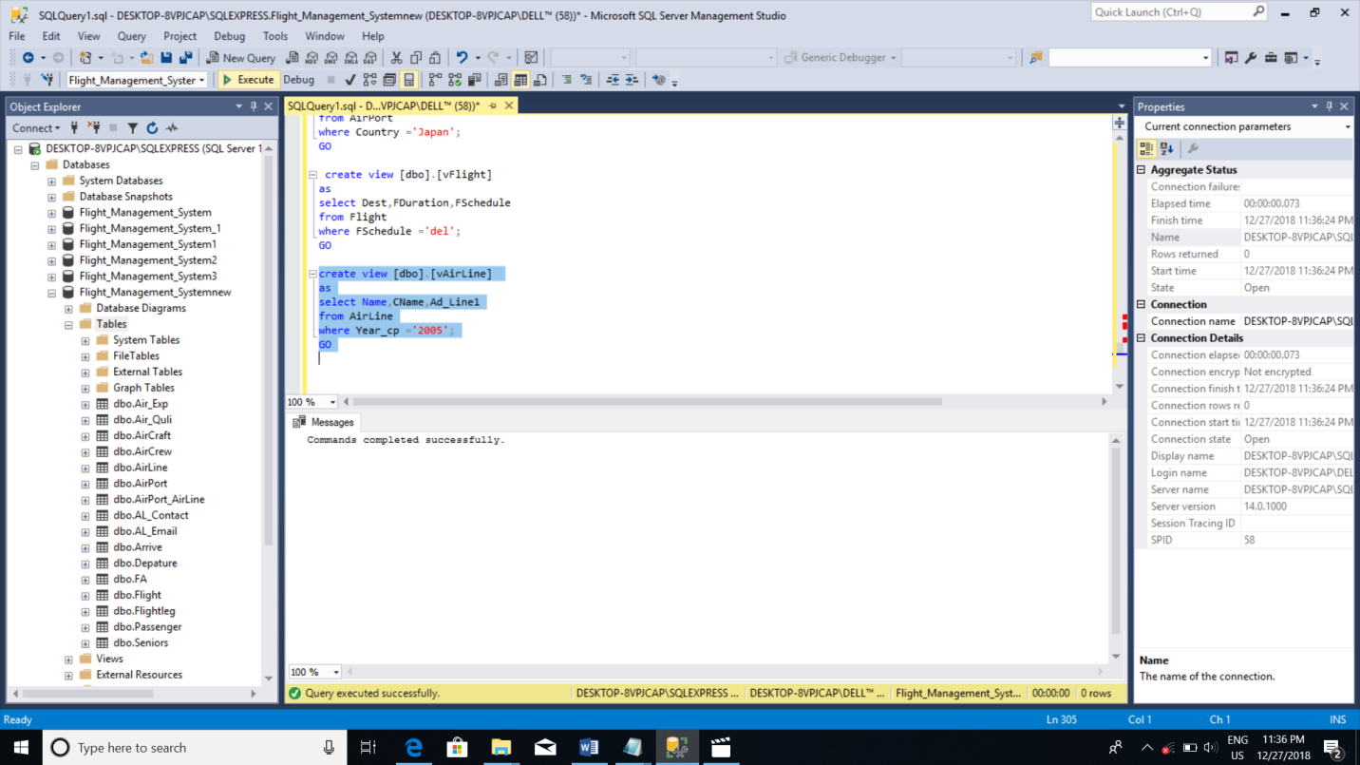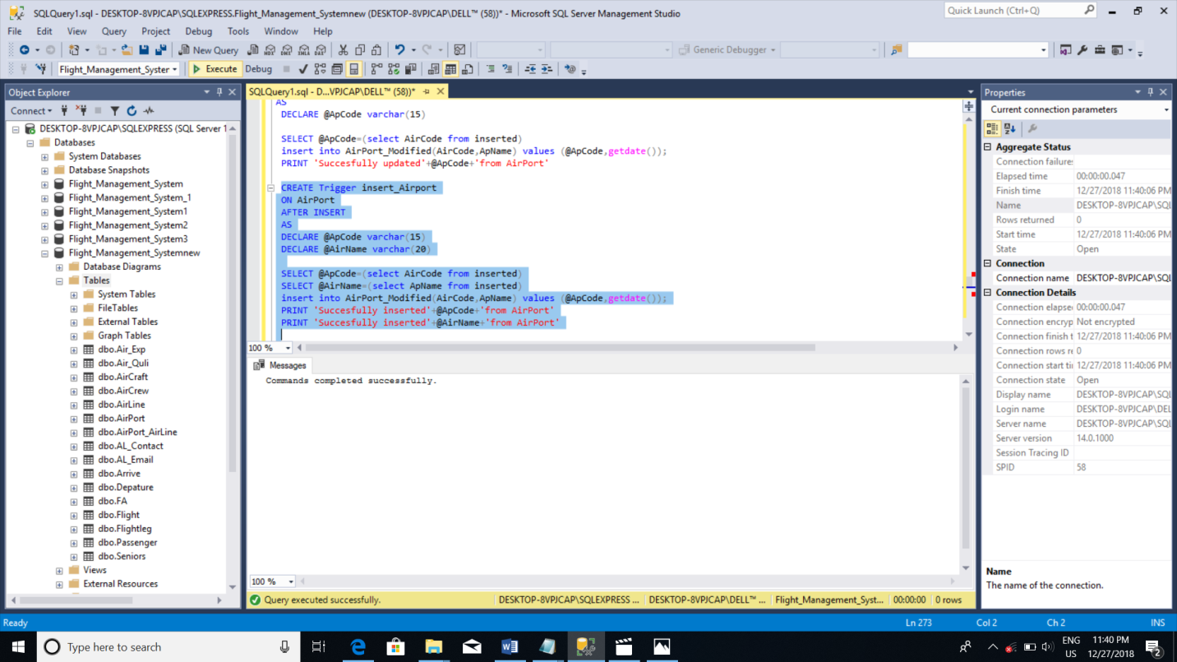

## Microsoft SQL Server Create View Statements

create view [dbo].[vAirPort]

as

select ApName,City,Country,E_Year

from AirPort

where Country ='Japan';

GO

create view [dbo].[vFlight]

as

select Dest,FDuration,FSchedule

from Flight

where FSchedule ='del';

GO

create view [dbo].[vAirLine]

as

select Name,CName,Ad_Line1

from AirLine

where Year_cp ='2005';

GO

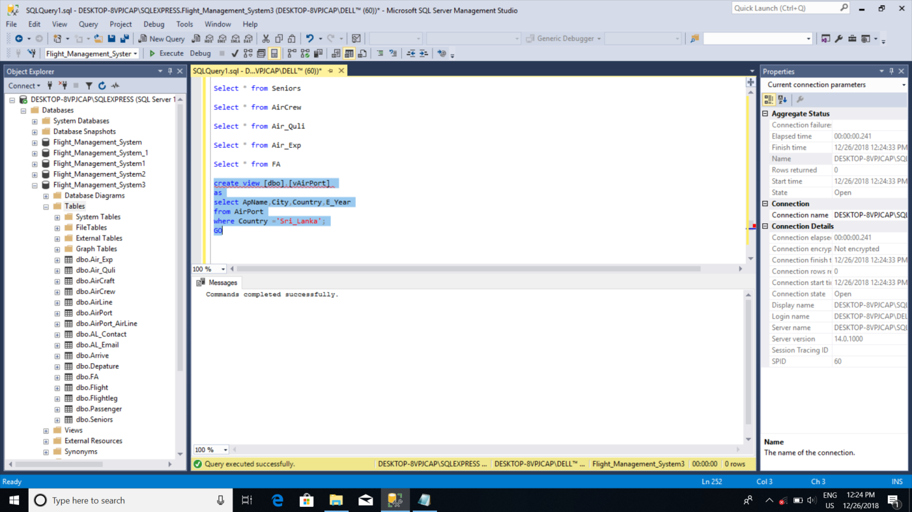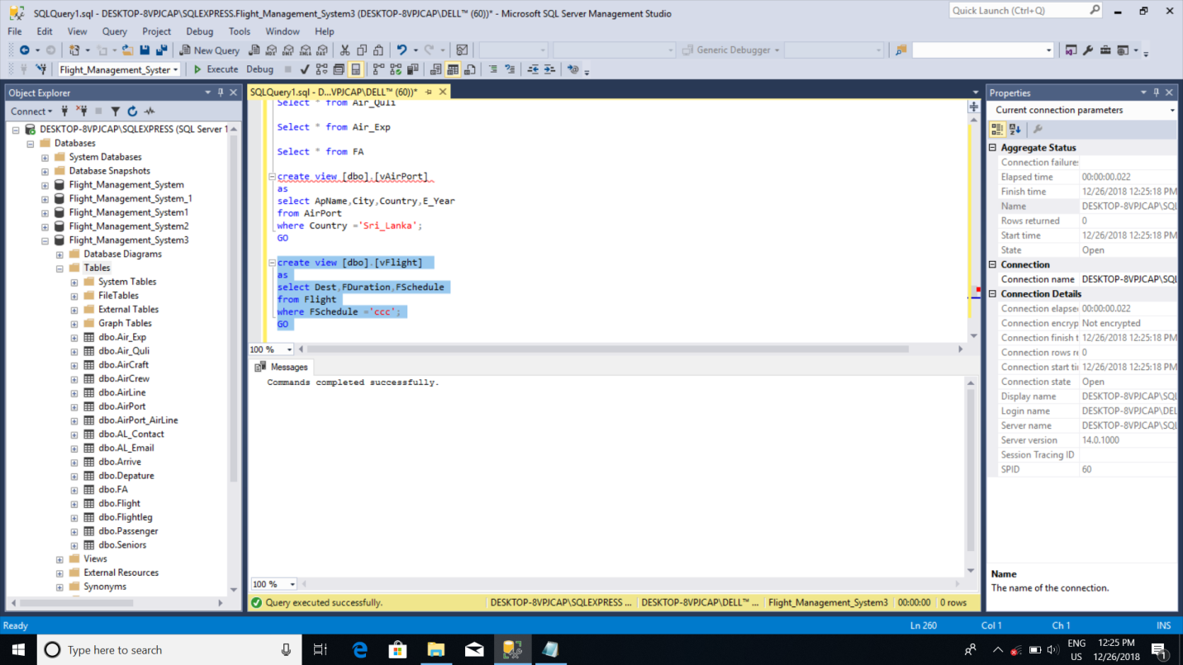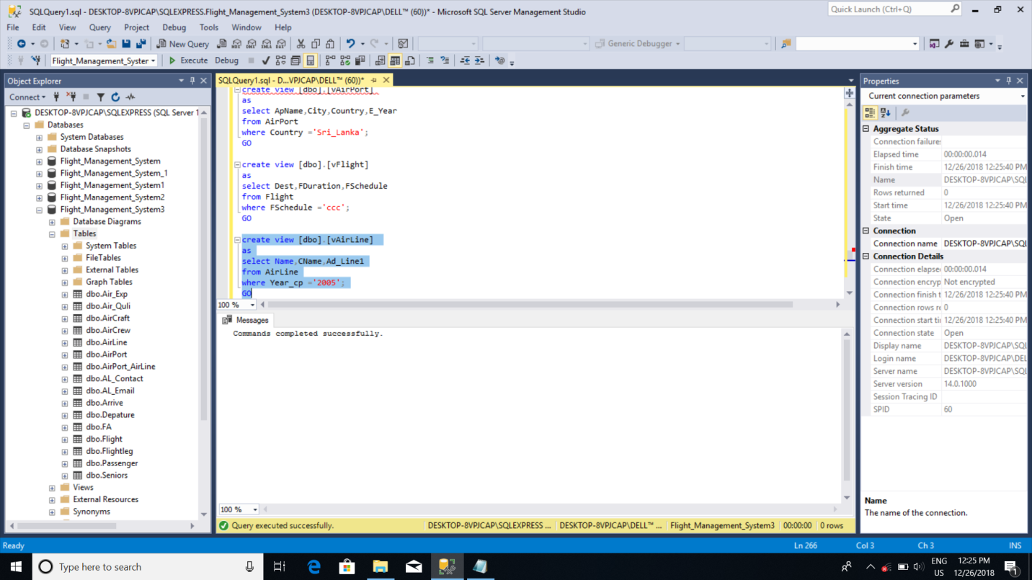

## Microsoft SQL Server Create View Statements

CREATE PROCEDURE spgetairline

AS

BEGIN

select AlCode,Name,Cname,Ad_Line1,Ad_Line2,Ad_Line3,Year_cp,NumofDes,WebsiteURL

from AirLine

where NumofDes='30'

END

CREATE PROCEDURE spgetairport

AS

BEGIN

select AirCode,ApName,City,Country,E_Year

from AirPort

END

Go

select @ AlCode,Name,Cname,Ad_Line1,Ad_Line2,Ad_Line3,Year_cp,NumofDes,WebsiteURL

print @ Name,Cname,Ad_Line1,Ad_Line2,Ad_Line3,Year_cp,NumofDes,WebsiteURL

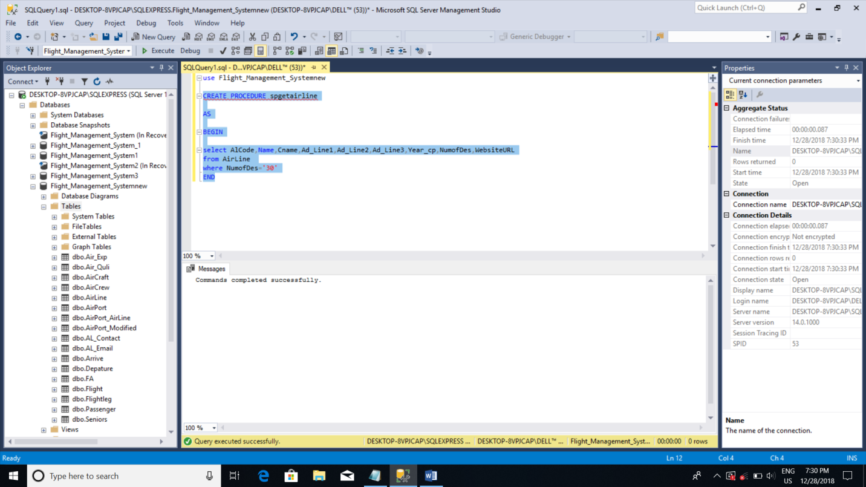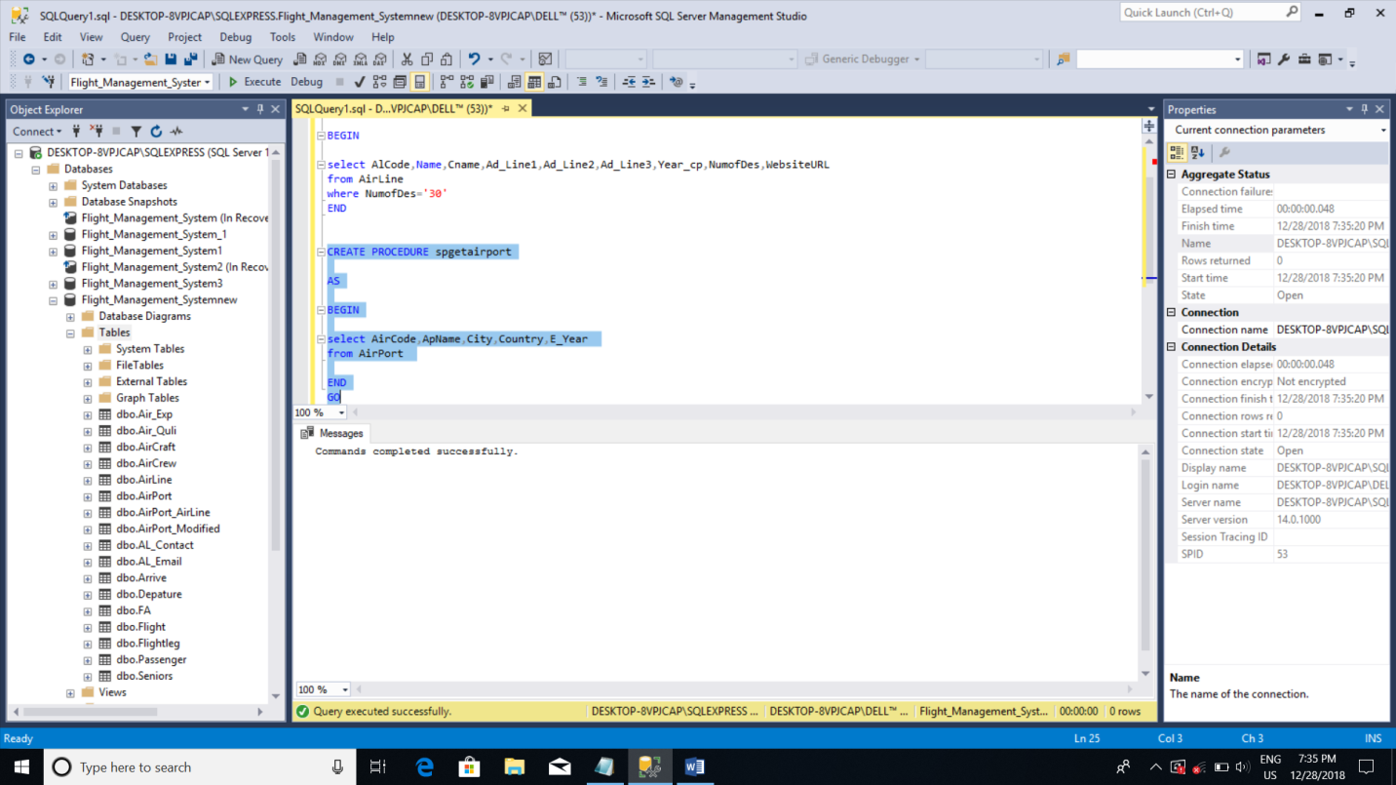

1. **Section 4**

4.1. Future implementation

We hope to more develop this database and use to more data. As improve the large database. This database we created to Mihin air international airport but we hope to implement for this database as another airport, another country.

This is not more complexity but we hope to this develop the large and not complexity database. And we hope add to this database more feasters and improve the flexibility .

## 4.2. Peer Review

|  |  |
| --- | --- |
| **Evaluation Criteria** | **10638375** |
| Attends group meetings regularly and arrives on time. | 4 |
| Contributes meaningfully to group discussions. | 4 |
| Completes the tasks on time. | 3 |
| Prepares work in a quality manner. | 4 |
| Contributes significantly to the success of the project in a cooperative and supportive attitude. | 4 |
| **TOTAL** | **19** |

## Work Load Matrix

|  |  |  |  |  |  |
| --- | --- | --- | --- | --- | --- |
| **Index Number** | **ER/EER Diagram** | **Relational Mapping,  Data Normalization, Data Dictionary** | **Tables, Constraints** | **Views, Triggers** | **Stored Procedures, User Defined Functions** |
| 10638375 | x | x | x | x | x |

Turnitin Report

